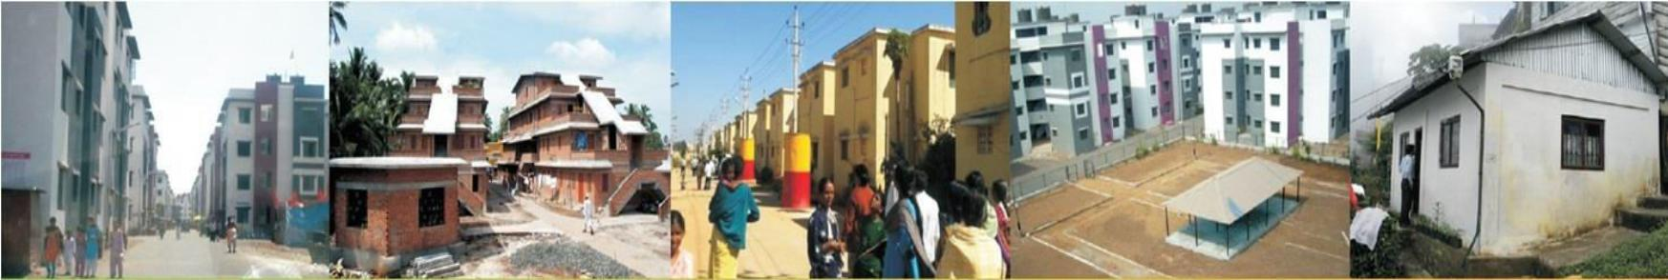



Housing For All Plan of Action (HFAPoA) Draft

Hailakandi Municipal Board, Assam

2015-2022
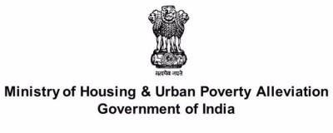

Submitted By- Municipal Board, Hailakandi
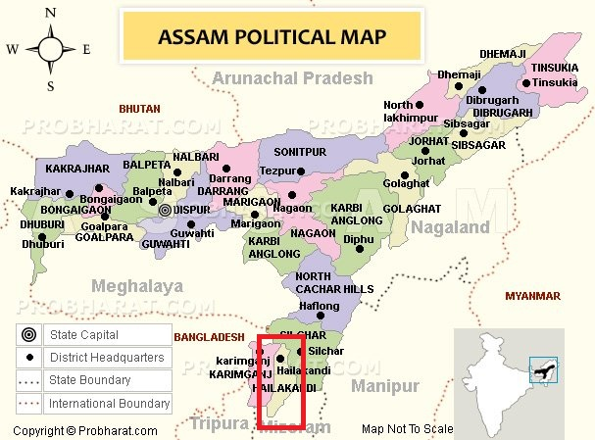

Picture: Map of Assam Showing Location of Hailakandi District

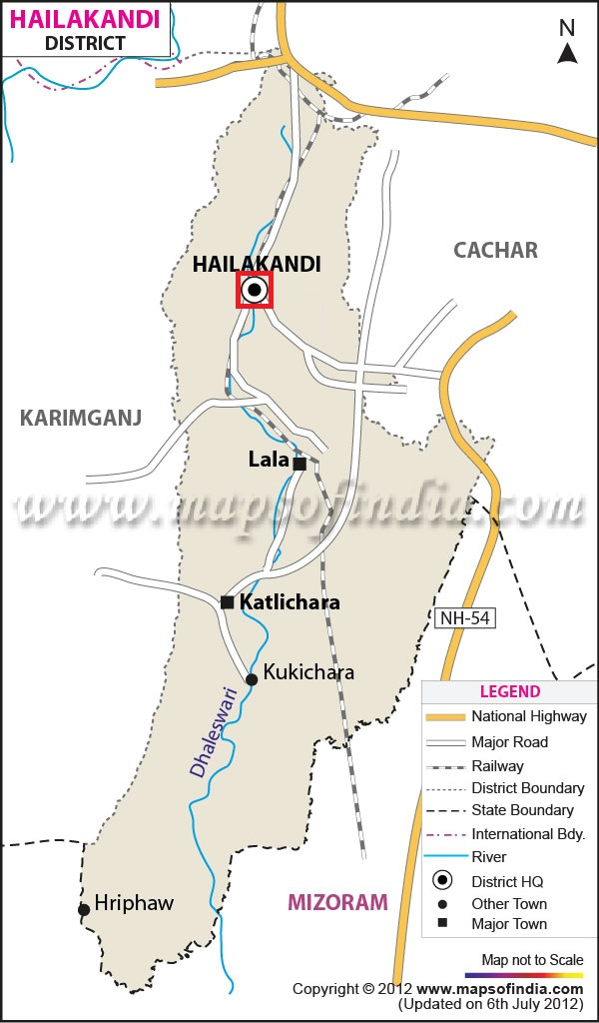

Picture: Map of Hailakandi District Showing Location of Hailakandi Town

CERTIFICATE

This is certify that the HFAPoA report of Hailakandi Town, is prepared by Officials of Hailakandi Municipal Board for implementation of various verticals of PMAY-HFA(U).

Name Designation Signature

- Bhadra Kanta Sharma Executive Officer, Hailakandi Municipal Board

- Shyamoli Roy Chairperson, Hailkandi Municipal Board

- Amalendu Roy Project Director, PMAY-HFA(U), Hailakandi

SUMMARY

Name of ULB: Hailakandi Municipal Board

District: Hailakandi

Sl No | Particulars | Unit
1 | Total Municipal Area (Sq.km) | 4.55
2 | Total Population  (Census 2011) | 33637
3 | Total no. of Slums (Nos.) | 0
4 | Total no. of Tenable Slums(Nos.) | 0
5 | Total no. of Untenable Slums (Nos.) | 0
6 | No of Slums proposed for In-Situ Redevelopment (Nos.) | 0
7 | Development verticals under PMAY-U | Total Beneficiaries (Nos.) | Slum Beneficiaries (Nos.) | Non Slum beneficiaries (Nos.) | Central Assistance (Rs in Crore) | State Assistance  (Rs in Crore)
i) | Beneficiary Led Construction & Beneficiary Led Enhancement | 1129 | 0 | 1129 | 16.935 | 5.645
ii) | In Situ Slum Redevelopment (through PPP) | 0 | 0 | 0 | 0 | 0
iii) | Affordable Housing in Partnership | 420 | 0 | 420 | 6.30 | 2.10
iv) | Credit Linked Subsidy | 88 | 0 | 88 | 2.3496 | 0

Abbreviation

A&OE : Administrative and Other Expenses
AHP : Affordable Housing in Partnership
AIP : Annual Implementation Plan
BMTPC : Building Materials & Technology Promotion Council
CNA : Central Nodal Agencies

CPHEEO : Central Public Health and Environmental Engineering Organisation
CSMC : Central Sanctioning and Monitoring Committee
CDP : City Development Plan
CLSS : Credit linked subsidy scheme
DIPP : Department of Industrial Policy and Promotion
DPR : Detailed Project Report

EWS : Economically Weaker Section
EMI : Equated Monthly Instalment
FAR : Floor Area Ratio
FSI : Floor Space Index
HUDCO : Housing and Urban Development Corporation
HFA : Housing for All
HFAPoA : Housing for All Plan of Action
IIT : Indian Institute of Technology
IS : Indian Standard
IEC : Information Education & Communication
IFD : Integrated Finance Division
LIG : Low Income Group

MoA : Memorandum of Agreement
MoU : Memorandum of Understanding
MoHUPA : Ministry of Housing and Urban Poverty Alleviation
MD : Mission Directorate
NBC : National Building Code
NHB : National Housing Bank
NPV : Net Present Value
NOC : No Objection Certificate
NA : Non Agricultural(NA)
PLI : Primary Lending Institution

RWA : Residents’ Welfare Association

SFCPoA : Slum Free City Plan of Action
SECC : Socio Economic and Caste Census

SLAC : State Level Appraisal Committee
SLNA : State level Nodal Agencies
SLSMC : State Level Sanctioning and Monitoring Committee
TPQMA : Third Party Quality Monitoring Agency
TDR : Transfer of Development Rights
UT : Union Territory
ULB : Urban Local Body
T&CP : Town & Country Planning
ASHB : Assam State Housing Board

CONTENTS

CHAPTER 1: INTRODUCTION

1.1 Project Overview/Background………………………………………………………………………………………….1

1.1.1 Urbanization and Housing Scenario in India……………………………………………………………….1

1.1.2 Slums Situation and Housing shortage in India…………………………………………………………..3

1.1.3 Challenges in Housing Sector……………………………………………………………………………………..4

CHAPTER 2: OVERVIEW OF PMAY (U)

2.1 Introduction to PMAY

2.1.1 Introduction………………………………………………………………………………………………………………6

2.1.2 Aim…………………………………………………………………………………………………………………………….6

2.1.3 Broad Objectives of the Plan………………………………………………………………………………………6

2.1.4 Entitled Towns for the Housing for All Plan of Action…………………………………………………7

2.1.5 Verticals…………………………………………………………………………………………………………………….7

2.1.5.1 “In-Situ” Slum Redevelopment…………………………………………………………………………8

2.1.5.2 Credit Linked Interest Subsidy………………………………………………………………………….9

2.1.5.3 Affordable Housing in Partnership…………………………………………………………………..10

2.1.5.4 Beneficiary-led individual house construction or enhancement……………………...11

2.1.6 Housing For All Plan of Action (HFAPoA)…………………………………………………………………..14

2.1.7 Framework Adapted to Prepare HFAPoA………………………………………………………………….14

2.1.8 Institutional Structure for PMAY……………………………………………………………………………….15

CHAPTER 3: CITY/TOWN PROFILE

3.1 General Profile of the Town…………………………………………………………………………………………….16

3.2 Location of the Town……………………………………………………………………………………………………….17

3.3 Climate…………………………………………………………………………………………………………………………….19

3.4 Linkages and Connectivity…………………………………………………………………………………………………19

3.4.1 Air Connectivity……………………………………………………………………………………………………………19

3.4.2 Rail Connectivity………………………………….………………………………………………………………………19

3.4.3 Road Connectivity……………………………………………………………………………………………………….19

3.5 Social and Demographic Profile………………………………………………………………………………………..20

3.5.1 Population Growth and Density………………………………………………………………………………….20

3.5.2 Literacy rate and Sex Ratio………………………………………………………………………………………….20

3.5.3 Social Groups………………………………………………………………………………………………………………21

3.5.4 Economic Profile…………………………………………………………………………………………………………22

3.6 Historical Background……………………………………………………………………………………………………….23

3.7 Natural Hazards of the Area………………………………………………………………………………………………23

3.8 Housing Scenario……………………………………………………………………………………………………………….24

3.8.1 Housing Condition Based On Structures………………………………………………………………………24

3.8.2 Type of Housing Material Used…………………………………………………………………………………...24

3.8.3 Existing Situation- Review of the Existing Policies, Programmes & Projects related to
the slum and Housing Initiatives…………………………………………………………………………………24

3.9 Identification of Existing Vacant Land………………………………………………………………………………..25

3.10 Physical Infrastructure……………………………………………………………………………………………………..26

3.10.1 Water Supply…………………………………………………………………………………………………………….26

3.10.2 Solid Waste Management…………………………………………………………………………………………26

3.10.3 Sewerage and sanitation system……………………………………………………………………………….26

CHAPTER 4: DEMAND ASSESSMENT IN SLUM AND NON-SLUM AREAS

4.1 Initiation of Demand Survey…………………………………………………………………………….………………27

4.2 Forms Collected and Data Entry Status…………………………………………………………………………….32

4.3 Validation of Forms………………………………………………………………………………………………………....32

4.4 Slum in Hailakandi Municipal Board…………………………………………………………………………………33

4.5 Checklist of Beneficiaries…………………………………………………………………………………………….……35

CHAPTER 5: INVESTMENT PLAN

5.1 Introduction………………………………………………………………………………………………………………………36

5.2 Institutional Framework for Implementation of HFAPoA…………………………………………………..36

5.3 In-Situ Slum Redevelopment Feasibility……………………………………………………………………………..36

5.4 Exploring Feasibility by Incentivizing Developer…………………………………………………………………38

5.5 Implementation /Planning process for ISSR, BLC and AHP………………………………………………….39

5.5.1 Slum-wise Intervention Strategies for Tenable Slums……………………………………………………40

5.5.2 Slum-Wise Intervention Strategies for Untenable Slum…………………………………………………41

5.5.3 Year-wise Proposed Interventions in Slums……………………………………………………………………42

5.5.4 Year-wise Proposed Interventions for Other Urban Poor Based on Demand Survey………43

5.6 Year-wise targets under different components……………………………………………………………………..44

5.7 Summary Sheet for Annual Implementation Plan………………………………………………………………….45

5.8 Conclusion…………………………………………………………………………………………………………………………….46

LIST OF TABLES:

Table-1.1: India: total, rural & urban population (In million) & Level of Urbanization……………………2

Table-3.1: Hailakandi Town at a glance………………………………………………………………………………………..16

Table-3.2: Physical Characteristics of Hailakandi Town…………………………………………………………………19

Table-3.3: The growth of population of Hailakandi town as recorded in the last decades……………20

Table-3.4: The basic population data of Hailakandi town as per Census 2011 is…………………………..21

Table-3.5: Caste wise population distribution of Hailakandi town as per Census 2011…………………21

Table-3.6: Religion wise population distribution of Hailakandi town as per Census 2011…………..22

Table-3.7: Distribution of town population as working forces of various occupational categories
as per Census 2011…………………………………………………………………………………………………….22

Table-5.1: Institutional framework at State, District and ULB level and their Roles and
Responsibilities………………………………………………………………………………………………………….36

Table-5.2: In-Situ Slum Redevelopment Feasibility……………………………………………………………………..37

LIST OF FIGURES:

Figure 1.1: Definition of Slums as per Census 2011………………………………………………………………………3

Figure 2.1: The four verticals of the scheme…………………………………………………………………………………7

Figure 2.2: Strategy for slum redevelopment using land as a resource…………………….…….………......9

Figure 2.3: Steps in Credit Link Subsidy scheme………………….……………………………………………………….10

Figure 2.4: Steps in Affordable Housing in Partnership…..……………………………………………………………11

Figure 2.5: Procedures to release subsidy………………………………………………………………......................12

Figure 2.6: Implementation of PMAY…………………………………………………………………………………………..13

Figure 2.7: Framework adapted to prepare HFAPoA…………………………………………………...................14

Figure 5.1: Institutional Framework for Implementation of HFAPoA..............................................39

LIST OF MAPS:

Map-3.1: Location map of Assam……………………………………………………………………………………………….17

Map-3.2: Map of Hailakandi District showing location of Hailakandi Town………………………………..17

Map-3.3: Hailakandi Town Map…………………………………………………………………………………………………18

LIST OF PICTURES:

Picture 4.1: Orientation at Hailakandi Municipal Board…………………………………………………………….27

Picture 4.2: Orientation at various wards of Hailakandi Municipal Board………………………………….28

Picture 4.3: PMAY Hoarding in front of Hailakandi Municipal Board Office……………………………….28

Picture-4.4: PMAY Information Board in Hailakandi D.C and Municipal Board Office………………..29

Picture-4.5: PMAY Leaflets in Hailakandi Town…………………………………………………………………………29

Picture-4.6: Miking in Hailakandi Town…………………………………………………………………………………….29

Picture-4.7: Form Collection at Hailakandi M.B Office……………………………………………………………....30

Picture-4.8: Data Entry by operators at Hailakandi M.B……………………………………………………………..30

Picture-4.9: PMAY-HFA(U) House Photo capturing…………………………………………………………………….31

Picture-4.10: Revenue Camp at Hailkandi Circle Office……………………………………………………………….32

Picture-4.11: Verification of forms By ULB Officials…………………………………………………………………….33

Picture-4.12: Verification of forms By ULB Officials along with ward commissioner……………………33

Pictures-4.13: Location of Naga Patty Sweeper Colony in Google map……………………………………….34

Chapter – 1: Introduction

1.1 Project Overview/Background

According to the World Bank report, 65.5 million Indians (according to 2011 census) live in urban slums and 13.7% of the urban population lived below the poverty line in 2011. There is a need to address this transformation of the country. As the country progresses towards industrialization, urbanization seems to be a part and parcel of the process. Therefore, there has been a renewed wave of interest and enthusiasm towards affordable housing for all in the country. The existing schemes for affordable housing in urban areas have been revamped and with the advent of the new government, new schemes have also been introduced. In 2015, the Pradhan Mantri Aawas Yojana was introduced and is in the process of being implemented in the next seven years. What matters most is to uphold and respect the dignity of each and every life an make sure that the best possible measures are taken to ensure the same.

1.1.1 Urbanization and Housing Scenario in India

Urbanization

In the words of Kingsley Davis, ‘Urbanization is a process of switch from spread out patterns of human settlement to one of concentration in urban centers. It is a finite process…a cycle through which nations pass as they evolve from agrarian to industrial society.’ Though migration is the key factor, other aspects such as the demand for economic employment, better educational opportunities, health facilities and higher standard of living act as major propellants contributing to the upward trend in urbanization.
According to the McKinsey Quarterly of July 2010, ‘urban expansion in India will happen at a speed quite unlike anything the country or the world has seen before. It took nearly 40 years (from 1971 to 2008) for India’s urban population to rise by nearly 230 million; it will take only half that time to add the next 250 million. This expansion will affect almost every state. For the first time in India’s history, five of its largest states will have more of their population living in cities than in villages.’
According to the High Power Expert Committee report of 2011 on Indian Urban Infrastructure and Services estimated that by 2031, India will have more than 87 metropolitan areas and the country’s urban population is likely to soar to over 600 million, adding about 225 million population to present urban population .And with urbanization comes the main problem of housing shortage. This is also

in line with the Sustainable Development Goal (SDG) number 11: to make cities and human settlements inclusive, safe, resilient and sustainable.

Table-1.1: India: total, rural & urban population (In million) & Level of Urbanization (In percentage): 1901 -2011

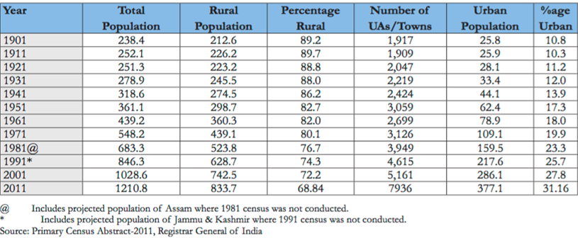

Housing scenario

Housing is a basic need and like any basic human need will be constantly in demand. Banks have played an important and inevitable role in providing houses for the citizens. The availability of institutionalized finance, as a regular source, has been almost absent as far as the average developer is concerned. This has been an area of major concern for the Builders. The more enlightened platforms of developers at National levels like CREDAI and NAREDCO have been trying to grapple with this matter to bring about some stability on this front. In fact the Housing Finance Companies and the representatives of the developers have been sitting together to thrash out some commonly agreed methods whereby finance to developers can be a more dependable arrangement.
Affordable housing is a particularly critical concern for low-income groups—in the absence of a viable model that caters to their needs, India can meet the challenge through a set of policies and incentives that will bridge the gap between price and affordability. This will enable a sustainable and economically viable affordable housing model for both government housing agencies and as well as private developers.
The total housing shortage at the end of tenth plan has officially been assessed as 24.71 million dwelling units for 67.4 million Households, where 98% of this shortage was in the Low Income and Economically Weaker Sections (EWS) segment. The situation even at the end of 11th Plan, despite efforts envisaged to implemented, is also not projected to improve, but rather this shortage is expected to escalate to 26.53 million houses for 75.01 million households.

1.1.2 Slum Situation and Housing Shortage for other Urban Poor in India

Slums

The word “slum” is often used to describe informal settlements within cities that have inadequate housing and miserable living conditions. They are often overcrowded, with many people crammed into very small living spaces. Slums have been a part of the history of almost all cities, particularly during the phase of urbanization and industrialization. Slums are generally the only type of settlement affordable and accessible to the poor in cities, where competition for land and profits is intense. The main reason for slum proliferation is rapid and non-inclusive patterns of Urbanization catalyzed by increasing rural migration to urban areas.

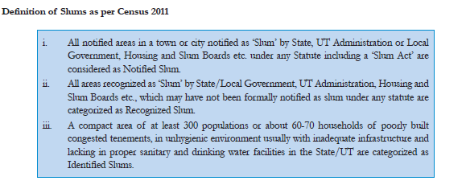
Figure-1.1: Definition of Slums as per Census 2011

Slums manifest deprivation that transcends income poverty. They are characterized by acute over-crowding, insanitary, unhealthy and dehumanizing living conditions. They are subject to insecure land tenure, lack of access to basic minimum civic services such as safe drinking water, sanitation, storm drainage, solid waste management, internal and approach roads, street lighting, education and health care, and poor quality of shelter.

Situation of Slums in India

Increase in Indian population over a period of time has also resulted in slum population growth. According to Government sources, the slum population of India has exceeded the population of Britain. It has doubled in last two decades, despite of Government efforts to build new houses and other basic infrastructure. Due to the shoot of urban dwellers, urban planners will face escalating challenges as these slums will mostly proliferate in sleepy towns and in semi-rural areas, a consequence of an accelerating rural to urban shift across the nation. According to data provided in Parliament, Maharashtra, Uttar Pradesh, Andhra Pradesh and Madhya Pradesh will host the largest chunks of India's slum population. But the census of 2011 recorded 1.3 crore urban slum households. The 2011 census shows the problem is growing as it indicates the percentage of people living in slums in smaller cities with a population of less than a million is rising. While 62% people in these cities are slum dwellers, it is 38% in all million-plus cities that include mega metros like Delhi and Mumbai. Census data also shows how a large section of the urban population lives in slums in the four metropolitan cities -- as high as 41.3% in Greater Mumbai, 29.6% in Kolkata, 28% in Chennai and about 15% in Delhi.

Housing Shortage for other Urban Poor in India

A Technical Committee under the Chairmanship of Dr. Amitabh Kundu, Professor of Economics JNU was set up by Ministry of Housing & Urban Poverty Alleviation to estimate the Urban Housing Shortage for the 12th Five Year (2012-17).The Technical Group has estimated that at the start of the 12th Five Year Plan (2012-17), the total housing shortage in the country is 18.78 million. The Technical Group also estimated that 95% of the urban housing shortages are coming from Economically Weaker Sections (EWS) and Lower-Income Groups (LIG). According to the MHUPA, around 18 million people are living in slums and nearly 2 million is to enter homeless category in near future. Hence there is a demand for 20 million (2crore) urban houses by 2022.

1.1.3 Challenges in the Housing Sector

Apart from food and clothing, housing is one of the basic necessities that are needed to ensure basic sustenance of individuals. India has witnessed rapid urbanization which has led to a drastic increase in demand for housing. With increasing projections/ figures around the number of people expected to make urban centers their home, the importance of this sector cannot be undermined. There are significant challenges that the housing sector in India faces:

- Unplanned growth of urban centres: Cities in India, as in the case of most cities in developing countries have experienced rapid, unplanned development. This haphazard, unchecked expansion of cities has significant ramifications. These projects/ settlements often exist without basic necessities and are not identified to be eligible for the same by development authorities in place.

- Connectivity: Due to the above mentioned unplanned expansion, localities have been pushed to the peripheries of the cities. Lack of integration with the comprehensive city master plan created by the authorities often leads to connectivity issues. Establishment of mass rapid transit systems (MRT) to felicitate commute can help address this challenge to housing in India.

- Financial illiteracy: There exists a sizable gap between the demand for and supply of housing in India. One of the reasons for the same can be attributed to lack of financial literacy and awareness amongst the economically weaker sections of people. This illiteracy hampers them from making informed choices and decisions and hence affects their ability to demand for good quality housing. The foray of banks and other Non-banking Financial institutions into the housing loan segment has helped increase awareness and demand for housing.

- Rising costs of construction: Constructions in urban areas are costly affairs with highly priced approval costs and high rates of interests against borrowings by developers. Obtaining clearances for projects and market fluctuations have also significantly increased costs of construction in cities.

- Lack of availability of land in urban areas: Due to the exorbitant prices of land in cities, acquiring the same for construction acts as a major deterrent for developers. Unfavourable development norms in urban areas and high, multiple taxes to be paid to development agencies act as significant challenges to the housing sector in India.

- High costs of ownership: The abovementioned factors coupled with multiple other costs like stamp duty, registration charges amongst others add to the cost of owning a house in the country. With the development of community based dwelling units and the creation of Resident welfare associations (RWAs), charges like maintenance and upkeep along with increase in additional facilities being provided increases the ownership costs.

- Lack of single window clearance systems: With multiple approvals that have to be obtained during the process of construction, the absence of a single window clearance system acts as a significant challenge.

- Sustainability issues: Sustainability is the need of the hour. Complying with environment norms and adjusting for eco system sensitivities has to be made commonplace. Incorporating elements of vernacular architecture into large scale housing projects makes increases the significance of the same. Congestion and the presence of obsolescence structures are counted amongst sizeable problems faced by urban space in India. Addressing this issue of sustainability increases the relevance of this form of intervention by the government.

Chapter – 2: Overview of Pradhan Mantri Awas Yojana

2.1 Introduction to PMAY

2.1.1 Introduction

The Hon’ble President of India, in his address to the Joint Session of Parliament on 9th June, 2014 had announced “By the time the Nation completes 75 years of its Independence, every family will have a pucca house with water connection, toilet facilities, 24x7 electricity supply and access.”
Hon’ble Prime Minister envisioned Housing for All by 2022 when the Nation completes 75 years of its Independence. In order to achieve this objective the Ministry of Housing and Urban Poverty Allevation (MoHUPA) has launched a comprehensive mission Housing for All (HFA) mission through Pradhan Mantri Awas Yojana (PMAY).
The PMAY –HFA (Urban) is to be implemented during 2015-2022 as a Centrally Sponsored Scheme. The Mission would provide central assistance to eligible families/beneficiaries by 2022. The Mission seeks to address the housing requirement of urban poor including slum dwellers for which all the states are required to prepare Housing for All Plan of Action (HFAPoA) with Annual Implementation Plan (AIP).

All 4041 statutory towns as per Census 2011 would be covered in three phases as follows:
Phase I (April 2015-March 2017): to cover 100 cities selected from States/UTs as per their willingness.
Phase II (April 2017-March 2019): to cover additional 200 cities.
Phase III (April 2019-March 2022): to cover all other remaining cities.

2.1.2 Aim

The aim of this Housing for All Plan of Action scheme is to provide shelter to the individuals who are homeless. The main focus of this government housing plan will be on the people who belong to Slums, LIG and EWS categories. The Action Plan also aims is to create an enabling environment for providing
“Affordable Housing for All” with special emphasis on BPL/ EWS/LIG and other vulnerable sections of society The Action Plan further aims to promote Public Private People Participation (PPPP)for addressing the shortage of adequate and affordable housing.

2.1.3 Broad Objectives of the Plan

- Reduce housing shortage for urban poor (both residing and slum and non- slum areas)
- Ensure a regular affordable supply of affordable housing units to satisfy/meet growing demand in the cities.
- Ensure that all dwelling units have access to basic physical and social infrastructure like sanitation facilities, drinking water, electricity roads and other livelihood infrastructure.
- Encourage private developers of all scale in construction of EWS/LIG categories of houses.
- Create rental housing as transit accommodation for migrant to urban areas.
- Slum rehabilitation of slum dwellers with participation of private developers using land as a resource.
- Promotion of Affordable Housing for the weaker section through the credit linked subsidy.
- Affordable Housing in Partnership with Public and Private sector.

2.1.4 Entitled Towns for the Housing for All Plan of Action

The scheme will cover the entire urban area consisting of 4041 statutory towns with initial focus on 500 Class I cities and it will be implemented in three phases as follows, viz. Phase-I (April 2015 - March 2017) to cover 100 Cities to be selected from States/UTs as per their willingness; Phase - II (April 2017- March 2019) to cover additional 200Cities and Phase-III (April 2019 - March 2022) to cover all other remaining Cities.

2.1.5 Verticals of PMAY

The scheme will be implemented under the following four verticals.

Figure-2.1: The four verticals of the scheme

2.1.5.1 “In-Situ” Slum Redevelopment

This vertical follows the concept of using land as a resource with private
participation. The slums may be located on Central Government land/State
Government land/ULB land. Under this vertical, on an average slum rehabilitation
grant of Rs. 1 lakh per house is decided. The flexibility is given to States/Cities to
deploy this central grant for other slums being redeveloped. The states/cities can
also provide additional FSI/FAR or TDR to make the projects financially viable. The
land cost cannot be charged by Central Govt. agencies. For slums on Private Owned
Land, States/Cities can provide additional FSI/FAR or TDR to land owner as per its
policy but there will be no Central Assistance.
The State shall also identify all tenable slums and their parameters such as area,
available FSI, market potential etc. and examine financial and technical viability of all tenable slums for redevelopment with private partner using land as a resource. Additional FSI/FAR, TDR, relax density norms, mixed usage of land and Cluster of slums as single project can be considered as options.

There are two components involved in in-situ redevelopment:

(i) Slum rehabilitation component: provides housing along with basic civic
infrastructure

(ii) Free sale component: available to developers for selling in the market so as
to cross subsidize the project. The sale of “free sale component” should be linked to the completion and transfer of slum rehabilitation component. Only the required slum land will be given to private
developers. It is envisaged to have consultations with Slum Dwellers’ Associations
for formulating projects. All financial and non-financial incentives and concessions
are to be declared ‘a priori’ in the bid document. The private partner is to be selected
through open bidding process.

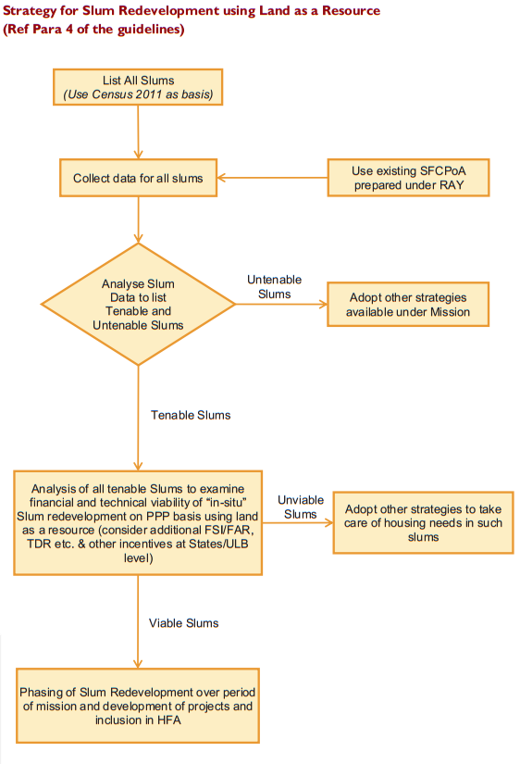

Figure-2.2: Strategy for slum redevelopment using land as a resource

2.1.5.2 Credit Linked Interest Subsidy
This vertical is basically demand side intervention where interest subvention on
home loans taken by eligible urban poor (EWS/LIG) for acquisition, construction or enhancement of house. The interest subsidy of 6.5% is available on housing loans up to Rs. 6 lakhs with tenure of 20 years for EWS/LIG, loans and beyond Rs. 6 Lakhs at market rate. Interest subsidy calculated on NPV basis @9% discount rate. The Subsidy credited upfront to the loan account of beneficiaries through lending institutions. The Carpet area limited to 30 sq. m. and 60 sq. m. for EWS and LIG respectively. The preference will be given to Manual Scavengers, Women/widows, SC/ST/OBCs, Minorities, differently-abled and Transgender subject to them being EWS/LIG. Self-certificate/affidavit as proof of income is to be submitted from loan applicant. The Central Nodal Agencies (CNAs) to channelize subsidy to the lending institutions and for monitoring the progress:
- Housing and Urban Development Corporation (HUDCO)
- National Housing Bank (NHB)
(NHB)The PLIs can sign MoU with only one Nodal Agency and PLIs to take NOCs quarterly from States/UTs or designated agency for list of beneficiaries covered under credit linked subsidy to avoid duplication.

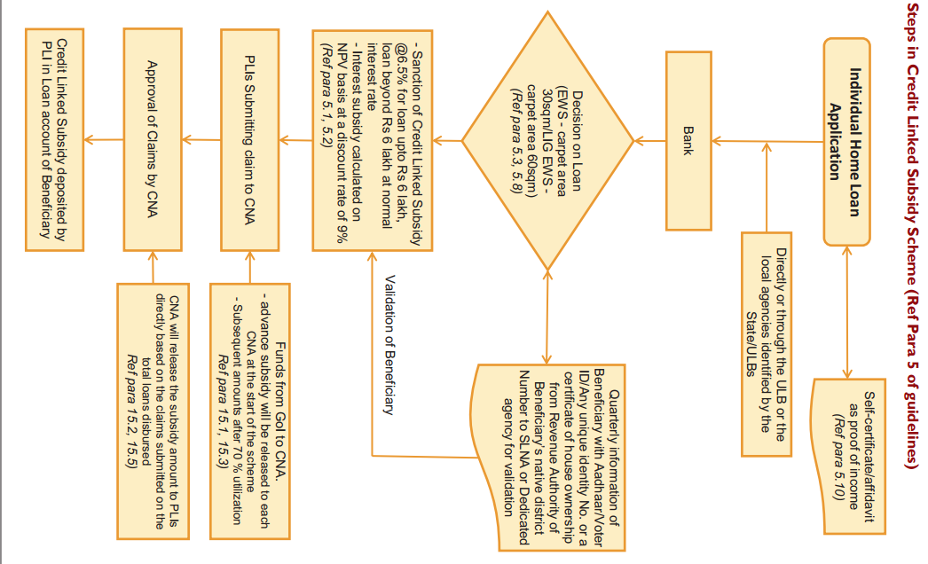
Figure-2.3: Steps in Credit Link Subsidy Scheme

2.1.5.3 Affordable Housing in Partnership
This is a supply side intervention to provide financial assistance to EWS houses
being built in different partnerships by States/UTs/Cities including private sector and
industries. The Central assistance @ Rs.1.5 lakh per EWS house is applicable. The
Affordable Housing project eligible for central assistance includes:

- At least 35% households for EWS Category
- Project of at least 250 houses.
The allotment will be through transparent procedure as approved by SLSMC to
beneficiaries identified in HFAPoA. The preference will be given to physically
handicapped persons, senior citizens, SC/ST/OBCs, minorities, single women,
transgender and other weaker and vulnerable sections of the society. The different models of private sector involvement prevailing in states can be adopted by others. The States/UTs will decide an upper ceiling of sale price for EWS houses.

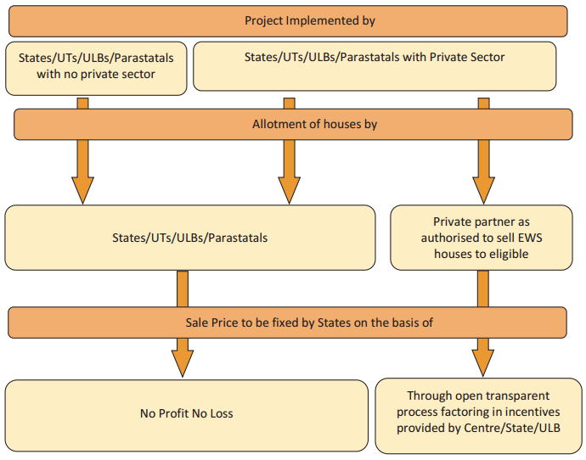

Figure-2.4: Steps in Affordable Housing in Partnership

2.1.5.4 Beneficiary-led Individual House Construction or Enhancement
The strategy is to provide assistance to individual eligible families belonging to EWS categories to either construct new houses or enhance existing houses on their own. The Central assistance @ Rs. 1.5 lakh per house will be given. The beneficiaries, in or outside slums, will have to approach ULBs with proof of land/house ownership. The Kutcha houses in slums which have not taken up for
redevelopment can be covered. The ULBs have to ascertain ownership of land, economic status and eligibility etc. of beneficiary. The socio-economic Caste Census (SECC) data will be used to verify current housing status of applicant and consequent eligibility. The ULBs will have to prepare integrated city wide individual housing project. The individual applicants for assistance shall not be considered. The states/ UTs/ Cities will ensure that GoI assistance is committed only after balance cost of construction is tied up. The State/UT or cities may contribute financially.
- Central assistance will be released in the bank account of identified beneficiaries through state/ UTs.
- GoI contribution to be released in proportion to the value of construction in 3-4 instalments.
- Last instalments of Rs.30,000 of GoI assistance to be released only after completion of house.
- Mechanism to track progress of such individuals through geo-tagged photographs
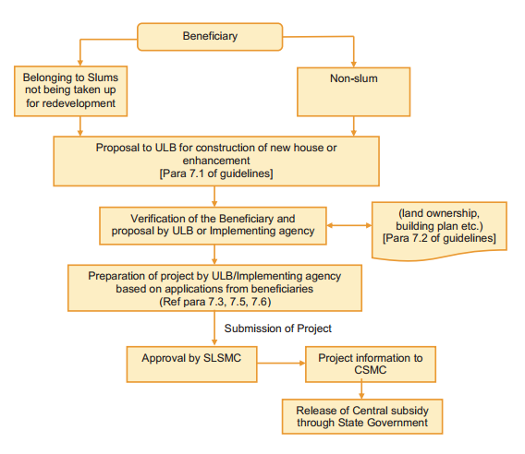
Figure-2.5: Procedure to release subsidy

Implementation of PMAY

Figure-2.6: Implementation of PMAY

2.1.6 Housing For All Plan of Action (HFAPoA)
HFAPoA is an important instrument for cities to attain the objective of PMAY. It is a Town wide plan of action which consists of two parts, a plan to bring about the improvement of the existing slums (Curative Strategy) through the participation of the existing slum dwellers and strategies for prevention of future slum (Preventive Strategy).The HFAPoA planning exercise will help the town to take a holistic view on housing for the urban poor, lead to systematic data gathering and analysis for structuring a town wide strategy on urban poor housing, which could further lead to town level proposals; zone, ward and slum level proposals, as well as proposals which would help to address structural issues which have constrained the access to affordable shelter solutions for the urban poor in the town in the past.

2.1.7 Framework adopted for preparation of HFAPoA
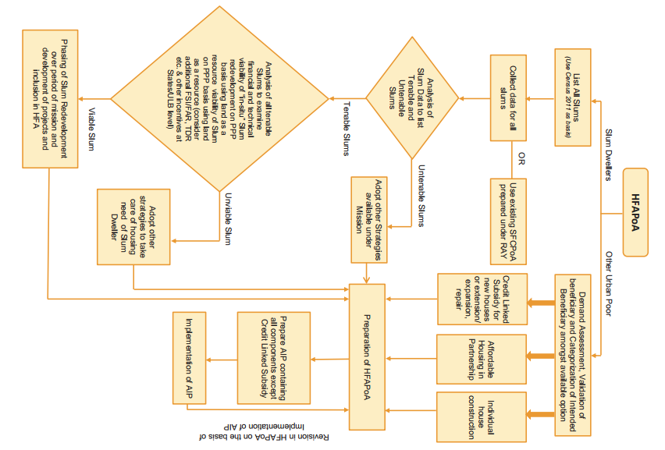

Figure-2.7: Framework adapted to prepare HFAPoA

2.1.8 Institutional Structure for PMAY

The program has the following institutional structure:

- An inter-ministerial committee viz. Central Sanctioning and Monitoring Committee (CSMC)is constituted under the Chairpersonship of Secretary (HUPA) for implementation of the Mission, approvals there under and monitoring.
- A Committee of Secretary (HUPA) and Secretary (DFS) in Government of India is also constituted for monitoring the credit linked subsidy component of the Mission, giving targets to PLIs etc.
- A Mission Directorate (MD) is also formed under the Ministry to implement the Mission. It is headed by Joint Secretary (Mission)
- States/UTs are required to constitute an inter-departmental State Level Sanctioning &
Monitoring Committee (SLSMC) for approval of Action Plans and projects under various
components of the Mission. The Committee should be headed by Chief Secretary.
- Each State/UT will identify a State Level Nodal Agency (SLNA) under the Mission wherein a State Level Mission Directorate will be set up for coordination of the scheme and reform related activities.
- State Level Appraisal Committee (SLAC) may be constituted by the State /UT for techno economic appraisal of DPRs submitted by ULBs/Implementing Agencies.
- A city level Mission for selected cities should be set up under the chairpersonship of the
Mayor or Chairman of the ULB as the case may be.

- Suitable grievance redressal system should be set up at both State and City level to address the grievances in implementing the mission from various stakeholders.

Chapter – 3: City / Town Profile

3.1 General Profile of the Town

Hailakandi is a town and the district headquarters of Hailakandi district in the Indian state of Assam. Hailakandi is located in the Southern part of Assam, popularly known as Barak Valley at 92°32’ East longitude and 24°46’ North latitude and 350 km away from the state capital Dispur. Hailakandi is one of the fastest forward marching town in the Barak Valley region Of Assam. Hailakandi is a Municipal Board city in the district of Hailakandi, Assam. The Hailakandi city is divided into 16 wards for which elections are held every 5 years. The Hailakandi Municipal Board has population of 33,637 of which 16,843 are males while 16,794 are females as per report released by Census India 2011. The area of Hailakandi town is 4.55 Sq.km. Primarily being an administrative town almost all the administrative headquarter of the district are located here. The main language of the town is Sylheti, though the official language is Bangla. There are also some speakers of Bishnupriya Manipuri and Meitei (also Manipuri).

Table-3.1: Hailakandi Town at a glance

Sl No. | Indicator | 2011
Sl No. | Indicator | Municipal Area
1 | Total Area (in Sq Km) | 4.55
2 | Number of Municipal Wards | 16
3 | Total Population (in lacs) | 33637
4 | Density of Population (persons per sq km) | 7393
5 | Number of Households | 7000
6 | Total Area of Slums (Sq. Km) | 0
7 | Total number of slums | 0
8 | Total Slum Population | 0
9 | Total Slum Households | 0
10 | Slum households as percentage of total Households in city | 0
11 | Slum population as percentage of total population in city | 0

3.2 Location of the Town

Hailakandi is a town and the district headquarters of Hailakandi district in the Indian state of Assam. Hailakandi is located in the Southern part of Assam, popularly known as Barak Valley at 92°32’ East longitude and 24°46’ North latitude and 350 km away from the state capital Dispur. The district is bounded by River Barak and Cachar district in the North & East respectively, Mizoram state in the South and East and Karimganj district in the West. The district has an inter-state border with Mizoram on its South-East having a length of 76 km.

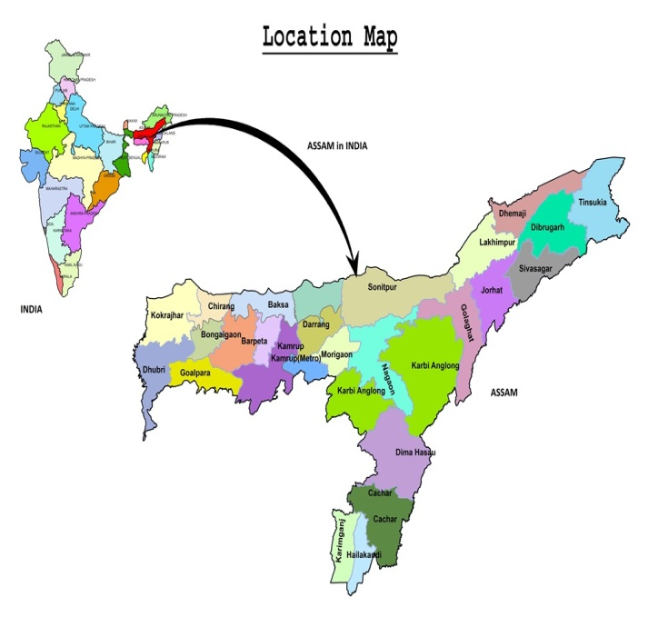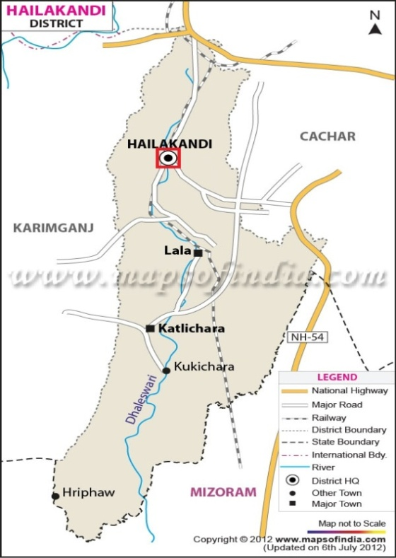

Map-3.1: Location map of Assam Map-3.2: Map of Hailakandi District showing
location of Hailakandi Town

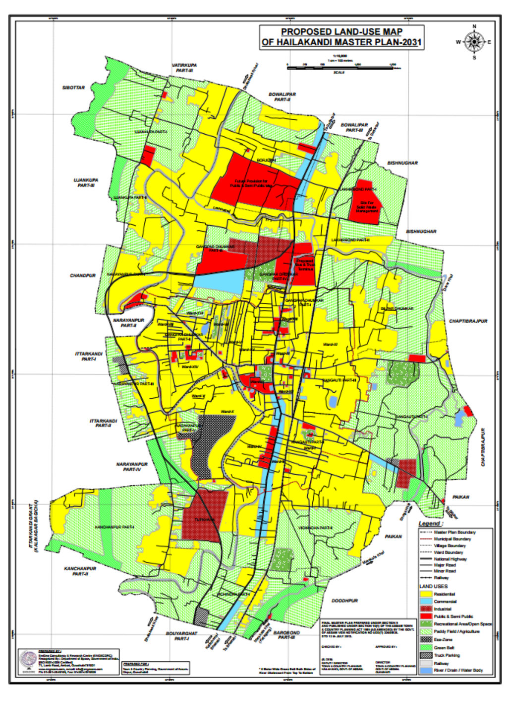
Map-3.3: Hailakandi Town Map

3.3 Climate

The climate in the town is characterized by moderate temperatures and is highly humid in nature. The summer season is from March to June. The rainy season is from June to September and the winter starts from November and lasts till the end of February. The mean daily temperature of Hailakandi town ranges between 8°C to 26.5°C during winter. During summer, the mean daily temperature of Hailakandi town ranges between 22.5°C to 37°C. January is considered to be the coldest month and June is considered to be the hottest month of the season for Hailakandi town. The afternoon humidity of the town ranges between 40% to 81%. The maximum relative humidity is 85.5% and minimum relative humidity is 52% as per record available. The average rainfall of Hailakandi town is 2466 mm as per census 2011.

Table-3.2: Physical Characteristics of Hailakandi Town

Parameter | Description
Temperature | 37°C (Maximum), 8°C (Minimum)
Extreme months | June (in summer), January (in winter)
Humidity | 85.5% (Maximum), 52% (Minimum)
Rainfall | 2466 mm annually
Monsoon Period | May to September

3.4 Linkages and Connectivity

3.4.1 Air Connectivity

The nearest airport of Hailakandi town is Kumbhirgram, Silchar, which is located at a distance of 52 K.M.

3.4.2 Rail Connectivity

Hailakandi Town has a railway station called Hailakandi Railway Station. Nearest Rail stations are Hailakandi and Badarpur. The Railway line runs through Hailakandi district up to the border of Mizoram state.

3.4.3 Road Connectivity

Hailakandi town is well connected by roadways to the rest of the country. Direct bus services are there between Lala and other places of the state. There two National Highway in the district- N.H 53 passes through the East and North side of the district covering a distance of 20 km and another N.H 154 passes through the middle of the Hailakandi district from Dhaleswari to Mizoram border covering a distance of 92 km. Besides that, there are 473 km of PWD roads which runs through the district and connects more than 400 villages with the district Headquarter. As per Economic Survey, Assam, 2011-2012 in Hailakandi district there is 292 Kms of Black Topped and 181 Kms of Earthen/Gravel PWD roads.
The lengths of Roads according to different classes under PWD are mentioned as under:
1. State Highway: 17Km
2. Major district Road : 99 Km
3. Rural Road : 351 Km
4. Urban Road : 6 Km

3.5 Social and Demographic Profile

3.5.1 Population Growth and Density

The population of Hailakandi for a long period, after the beginning of its current era of development in the early 19th Century A.D. is largely a matter of conjecture. The first systematic attempt at an enumeration of the whole province of Assam was taken in 1872 when Assam was a part of Bengal. Hailakandi at that time was little more than a village. The Census Reports of India gives an idea of the increase in its population from 1462 in 1911 to 33637 in 2011. Apart from normal population a large number of employees, small businessmen, day laborers and other people come in this town every day.
Hailakandi is a Municipal Board city in district of Hailakandi, Assam. Out of 16 Wards of Hailakandi town, Ward No. 01 is the most populous ward with population of 3181 and Ward No. 15 is the least populous ward with population of 1007. The Hailakandi Municipal Board has population of 33,637 of which 16,843 are males while 16,794 are females as per report released by Census India 2011. Population of the Hailakandi town has increased by 13.1% in last 10 years, i.e. , from 2001 to 2011.There are 7000 households in the town and an average 4.8 persons live in every family. Population density of the city is 7393 persons per Sq. km.

Table-3.3: The growth of population of Hailakandi town as recorded in the last decades

Census Year | Male Population | Female Population | Total Population | Increase or Decrease in Population
1911 | 988 | 474 | 1462 | ---
1921 | 1595 | 633 | 2228 | 766
1931 | 1290 | 712 | 2002 | -226
1941 | 1884 | 1200 | 3084 | 1082
1951 | 4590 | 3629 | 8219 | 5135
1961 | 7646 | 6486 | 14132 | 5913
1971 | 8772 | 7872 | 16644 | 2312
1981 | --- | --- | --- | ---
1991 | 13131 | 12348 | 25479 | 8835
2001 | 15195 | 14544 | 29739 | 4260
2011 | 16843 | 16794 | 33637 | 3898

3.5.2 Literacy rate and Sex Ratio

As per the Population Census 2011, the Hailakandi Municipal Board has population of 33,637 of which 16,843 are males while 16,794 are females as per report released by Census India 2011. In Hailakandi Municipal Board, Female Sex Ratio is of 997 against state average of 958. Moreover Child Sex Ratio in Hailakandi is around 973 compared to Assam state average of 962. Literacy rate of Hailakandi city is 92.08 % higher than state literacy of 72.19 %. In Hailakandi town, Male literacy is around 94.61% while female literacy rate is 89.55%.

Table-3.4: The basic population data of Hailakandi town as per Census 2011 is given below:

Name of City/Town |  | Hailakandi Municipal Board
Total Population |  | 33637
Male Population |  | 16843
Female Population |  | 16794
Total Child Population (0-6 years age) |  | 3309
Male Child Population (0-6 years age) |  | 1677
Female Child Population (0-6 years age) |  | 1632
Literacy Rate |  | 92.08%
Male Literacy Rate |  | 94.6%
Female Literacy Rate |  | 89.5%
Sex Ratio |  | 997
Sex Ratio Child |  | 973
Growth of Population | 13.1%
Population Density | 7393 per Sq. K.M

3.5.3 Social Groups

Caste wise distribution of population

The caste system has played a very important role in the Indian society. It is an important part of our social structure. Hailakandi town is a multi-caste area. The main castes living in the town are Brahmin, Kayastha, khastriya, jogi, marwari, kamar, kumar, teli, barui etc. There are other castes also but they are numerically negligible. These castes can be broadly divided into three categories, namely, the General castes, the Schedule Castes and the Schedule Tribes. The General castes traditionally occupy higher social status. In Hailakandi town, the General category of people is the dominant group. The reason is their numerical, social, political and economic strength. The Schedule Caste is the second dominant group with little numerical strength. The Scheduled Tribes has a very negligible proportion of population in the town.

Table-3.5: Caste wise population distribution of Hailakandi town as per Census 2011 is shown below:

 | Total Population | General | Schedule Caste | Schedule Tribe
Total | 33637 | 30794 | 2796 | 47
Male | 16843 | 15445 | 1375 | 23
Female | 16794 | 15349 | 1421 | 24

Religion wise distribution of population

Hailakandi is the centre of various Indian religions especially Hinduism and Islam. The main religions followed by the people are Hinduism, Islam, and Christianity. Hindus contribute 67% of the total population and are the largest religious community in the city followed by Muslims which contribute 32% of the total population.

Table-3.6: Religion wise population distribution of Hailakandi town as per Census 2011 is shown below:

 | Total | Hindu | Muslim | Christian | Sikh | Buddhist | Others
Total | 33637 | 22625 | 10687 | 76 | 10 | 2 | 237
Male | 16843 | 11211 | 5483 | 35 | 5 | 1 | 108
Female | 16794 | 11414 | 5202 | 41 | 5 | 1 | 129

3.5.4 Economic Profile

The Hailakandi town has a mixed economy. The population of the town is engaged in different types of occupation. The economy of Hailakandi town is based upon tertiary sector which includes trade and commerce and transportation as well as government jobs. Activities related to trade and commerce and transportation alone comprises of 34.65% of total employment of the town. It is expected that employment related to transportation and trade and commerce is going to increase further after the road linkage from Mizoram is established with the town. In the town of Hailakandi only 28.92% of the population is employed which is quite low as compared to the state figure (urban Assam) of 30.92% as per the 2001 census. It is found that such a low rate of employment of the town is due to the inadequate industrial infrastructure of the town. The total workers of the Hailakandi town is 11456, which is 34.06% of the town population (33637). The main workers are 9190, recorded as 27.32 % of the town population and marginal workers are 2266, recorded as 6.74 % of the town population. The total population of town is distributed as working forces of various occupational categories and is described in the table below :

Table-3.7: Distribution of town population as working forces of various occupational categories as per Census 2011

Item No. | Occupational Categories | Male Workers | Female Workers | Total Workers
1 | Main Workers | 7697 | 1493 | 9190
2 | Marginal Workers | 1054 | 1212 | 2266
3 | Non-Workers | 8092 | 14089 | 22181
4 | Cultivators | 98 | 29 | 127
5 | Agricultural Laborers | 41 | 21 | 62
6 | Household industry  workers | 97 | 294 | 391
7 | Other Workers | 8515 | 2361 | 10876
Hailakandi town is the main centre of trade and commerce of the district. With the expansion of the activities of a welfare state, there has been multiplicity of developmental departments and all of them have their offices in the town. There has been steady improvement in banking facilities. Major industrialization is spoken of as the panacea of the local life. There is no possibilities of exploring any kind of mineral deposit within the district itself. Therefore, for the future economic prospects of the town, the location of a large-scale industry is essential.

3.6 Historical Background

According to historians, the Kukies are the first inhabitant of the district of Hailakandi. Subsequently, the Bodo-Kacharies (Dimasas) entered into the plains and settled in different places scattered in the northern part of the district. Several myths are associated with the name ‘Hailakandi’. In Barak Valley dyke is constructed for protection of people and land from flood. This dyke is colloquially pronounced as ‘Ail’ Or ‘Hail’. In the Bodokachari Language ‘Kandi’ means temporary paddy land and this is how the district came to be known as ‘Hailkandi’ and then as ‘Hailakandi’. According to some historians the district got its name from the ‘kuki’ word ‘halam’ means a small state and the word ‘kundia’ meaning a plot of land for temporary ploughing. Another myth associated with the name of the district is sali paddy is grown abundantly as a staple food crop and from ‘sailkandi’ the district came to be known as Hailakandi.
After independence, Hailakandi was a part of Cachar district. During the more recent times, Hailakandi district was first made a Civil subdivision in 1869 and later was upgraded to district in 1989. During the pre-independence days, when the partition of India was being considered, Abdul Matlib Mazumdar (1890-1980) - MLA & Cabinet Minister of Assam opposed the partition which meant letting go of a major chunk of Assam as well. He is the reason that the Barak Valley region comprising Silchar, Cachar, Karimganj and Hailakandi are still a part of Assam in India. Later on, he also established centres of higher education in Hailakandi. The Kachari Kingdom and the British ruled over the Hailakandi region right up till Indian Independence. The Hailakandi region was also on the verge of being annexed to Pakistan post partition but it was MLA and Cabinet Minister of Assam - Abdul Matlib Mazumdar who prevented it and Hailakandi remained in the Indian Territory.

3.7 Natural hazard of the Area

Assam is situated in the north eastern direction of Bangladesh which is highly prone to cyclone/winds. Every year about 60% of the area are affected by cyclone in Bangladesh. District very close to Bangladesh are in very high damage zone due to close proximity of Bay of Bengal (which is a cyclone basin). As Hailakandi District is very close to Bangaladesh, it is more prone to cyclone/winds, where wind speed can reach up-to 55 m/s and may result into large scale damage.
Hailakandi District is a flood prone area. The most vulnerable area is within the jurisdiction of Algapur Hailakandi and Lala Development Block. During most of past floods in preceding year, it was experienced that the extent of damage was destructive. Major floods of most recent past that affected the Hailakandi District occurs in the Year 1993, 1997, 2002 , 2004 & 2007. The main river of the Hailakandi district – Dhaleswari is originated from northern part of Mizoram and is flowing towards north through the middle of the district. Due to the occurance of heavy rainfall in Mizoram, draining in Dhaleshwari river which flows through the middle of the Hailakandi district causes floods in the district. To give safeguard to Hailakandi town from the seasonal flooding by Dhaleswari river , long ago an artificial canal was dug out near Ganjakhouri village to divert the flow of Dhaleswari which is now bearing the name ‘Katakhal River’ and is joined to the river Barak.

3.8 Housing Scenario

3.8.1. Housing Condition Based on Structure (pucca, kutcha, semi pucca)

A ‘House’ is generally a single structure on the ground. Usually a structure will have four walls and a roof. Sometimes it is made up of more than one component unit which are used or likely to be used as dwellings (residences) or establishments. Many a times houses which have component units are seen to be used for a combination of purposes such as shop-cum-residence, workshop-cum-residence, office-cum-residence etc. But in some areas the very nature of construction of houses is such that there may not be any wall. Such is the case of conical structures where entrance is also provided but they may not have any walls. Therefore, such of the conical structures are also treated as separate houses. A mixture of Kutcha, Pucca and semi Pucca houses have been seen in the area with a significant number of Kutcha and Semi-Pucca houses. According to Census 2011 data, out of total 7000 number of households, 4366 are classified into Permanent, 2109 are Semi- Permanent, 383 are Temporary and 142 are unclassified type.

3.8.2 Type of Housing Material Used

Previously, it was a town with houses made mostly of raw materials. But with the growing urbanization, new innovations and techniques it has started building Pucca Houses.
Pucca Houses : Pucca houses refer to those houses whose walls & roofs are made of pucca materials, i.e., where burnt bricks, stone, cement, concrete is used for wall and stone and Burnt Brick, Stone, GI Sheet ,Concrete are used for roof.
Semi Pucca Houses : Semi Pucca Houses refer to those houses whose walls are made of Asbestors / Metal Sheet, Brick, Stone and Tiles, Stone, Asbestors Sheet, Metal Sheet are used for roof.
Katcha Houses : Katcha houses refer to those houses having wall and roofs made of Katcha materials, i.e., where, grass, leaves, reeds, bamboo, wood, Asbestor Sheet, mud, Plastic, Polythene and unburnt bricks are used for the construction of walls and grass, leaves, reeds, bamboo thatch, mud, Plastic, Polythene unburnt bricks and wood etc. are used for roofs.

3.8.3 Existing Situation- Review of the Existing Policies, Programmes and Projects Related to Slum and Housing Initiatives

The present situation of housing sector in the Hailakandi town is not satisfactory. The physical condition of a large number of houses is very poor. The condition of housing of people living in this area is also studied in order to understand the quality of the housing under Hailakandi Municipal Board. According to Census 2011 data, the quality of the housing condition is classified into three groups; Good, liveable and dilapidated. Out of the 7000 households in Hailakandi town, 4308 houses are Good, 2151 houses are liveable and the remaining 541 houses are Dilapidated. As per the Census 2011, there are 7000 number of households in Hailakandi the town. Out of which 62.37% (4366 nos.) households have Permanent houses, 30.12% (2109 nos.) households have Semi Permanent houses, 5.46% (383 nos.) households have Temporary houses and 2.02% (142 nos.) are unclassified. It is observed that most of the dwelling units are constructed in typical ‘Assam type’ with inclined roofs and single storied.
Housing is one of those basic social conditions that determine the quality of life and welfare of people and places. Rapid urbanization has placed remarkable strain on housing and services land. With the rapid urbanization and growing population in Hailakandi town, the demand for Housing also increases. The foremost problem, that the town must solve, is the provision of its housing accommodation for the low wages and low income groups. Due to low income capabilities, the housing shortage is more among the lower income group population. The gap between housing demand and supply is widening day by day giving way to unplanned development such as unauthorized colonies and squatter settlements.
As per Demand Survey under PMAY–HFA (U) there is a total shortages of 1802 nos. of houses up to 2022. Housing Demand at Hailakandi Town under different Vertical of PMAY is that, demand for BLC is 1121, for BLE is 173, for CLSS is 88, for AHP is 420. The data may vary at the time of implementation after due verification.
According to the MHUPA, around 18 million people are living in slums and nearly 2 million is to enter homeless category in near future. Hence there is a demand for 20 million (2 crore) urban houses by 2022. To meet this demand, the PMAY-HFA(U) will be implemented during 2015-2022 by providing central assistance to Urban Local Bodies (ULBs) and other implementing agencies through States/UTs.
In Past, no slum redevelopment projects or programmes has been done in Hailakandi town under the earlier mission of RAY or Integrated Housing and Slum Development Programme (IHSDP).

3.9 Identification of Existing Vacant Land

An analysis of the land use pattern of the town of Hailakandi states that around 25% of the land is used for residential purpose. Commercial activities occupy 3.5% of the total land of the town. Industrial activities cover hardly 1.2% of the total land area. Land under agricultural activities account for about 20% of the area. Similariy, public and semi-public activities cover 4.0% of the total urban area. Mixed land is a rare sense in Hailakandi town. A major portion of town is identified as low laying area and water bodies which account for around 20.5% of the total area of the town. In the town 2.0% of the land is under the category of open space and the remaining 23.8% of the land is laying vacant. The total area of the town is 4.55 sq.km.

3.10 Physical Infrastructure

3.10.1 Water Supply

The water supplied by the PHED Hailakandi through Municipality is not sufficient for the 30 thousand population of the town. The quantity, quality, pressure, and even the timings of supply of water is not satisfactory. In the town of Hailakandi piped water is supplied to a section of the people, rest of the population depends upon individual source of water like ponds, wells and tubewells.The underground water reserve of the town is in a satisfactory condition, hence it is felt that there will be no shortage of water for distribution in the town. Besides this Dhaleswari is flowing through the town from which water can be tapped for distribution if required in future.

3.10.2 Solid Waste Management

There is no planned solid waste management system or even a landfill site for scientific disposal of the solid waste at Hailakandi. One of the most appreciating facts in the town is that although there is no solid waste management system , still the town is more or less clean , as the citizens of town duly supported by the trading and business community are involved in making cleanness be themselves .

3.10.3 Sewerage and sanitation system

It is seen that the condition of drainage network of Hailakandi town is not as per the standard requirement. The town lacks an efficient and well planned drainage system. Some road side drains in the form of open drains (kutcha and pucca) and foothpath cum drains are in existence at present. But they have faulty network lacks in efficient discharge system. The carrying capacity of most of the drains have reduced and they also have discontinued flow condition along longitudinal reach. Silting and dumping of garbage itself in the drain have told upon heavily on free flowing of storm water in the drain. The overall drainage system is only storm water drainage system. The ultimate discharge from all the town drains is either into the river Dhaleshwari or into the low lying ditches/open area in the periphery of town.
Hailakandi town does not have a centralized sewerage network. Most of the people use individual safety tanks and pit latrines. Present mode of disposal is through conventional septic tanks with soak pit arrangements. All the holdings have individual septic tanks. There are no dry latrines. The treated effluent is mostly discharge into the roadside drains.

Chapter – 4: Demand assessment in Slum and Non-Slum areas
To have a successful implementation of the PMAY-HFA(U) the State/Cities has undertaken a demand survey through suitable means for assessing the actual demand of housing. While validating demand survey, States/Cities has considered possible temporary migration from rural areas to exclude such migrants from list of beneficiaries. On the basis of demand survey, the demand assessment on certain given criteria and other available data, cities has prepared Housing for All Plan of Action (HFAPoA).

4.1 Initiation of Demand Survey

The Demand Survey was conducted only after being sure about the 4 verticals of the scheme (see chapter 4) and accordingly the demand survey was initialized. The initiation was done as follows:
- Cutoff date of demand survey was fixed by the State.
- Meetings were held at ULB level to discuss about the scheme.
- Meetings were done at Ward level with stakeholders.
- House to house demand survey was conducted by the ULBs.
Orientation to ULB and Stakeholders

An Orientation cum workshop was arranged at Hailakandi Municipal Board in April’2017, in presence of the Executive Officer, Chairperson and ward commissioners of the Hailakandi Municipal Board along with Officials of Hailakandi Municipal Board. The objective of the workshop was to explain the scheme modalities, guidelines and Demand Survey Process. Apart from that 11 meeting were also done at ward level, to create Public awareness and to discuss about the scheme.
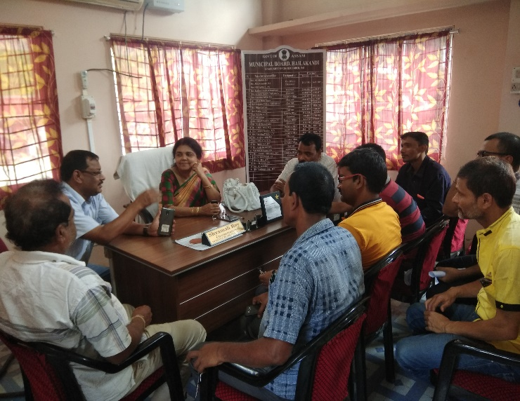
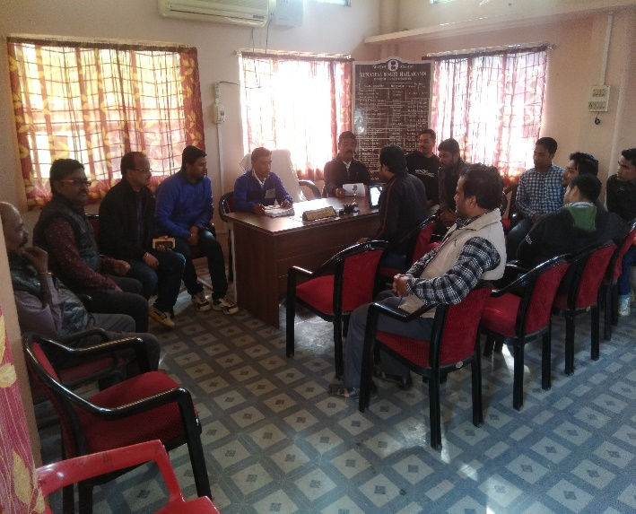

Picture 4.1: Orientation at Hailakandi Municipal Board

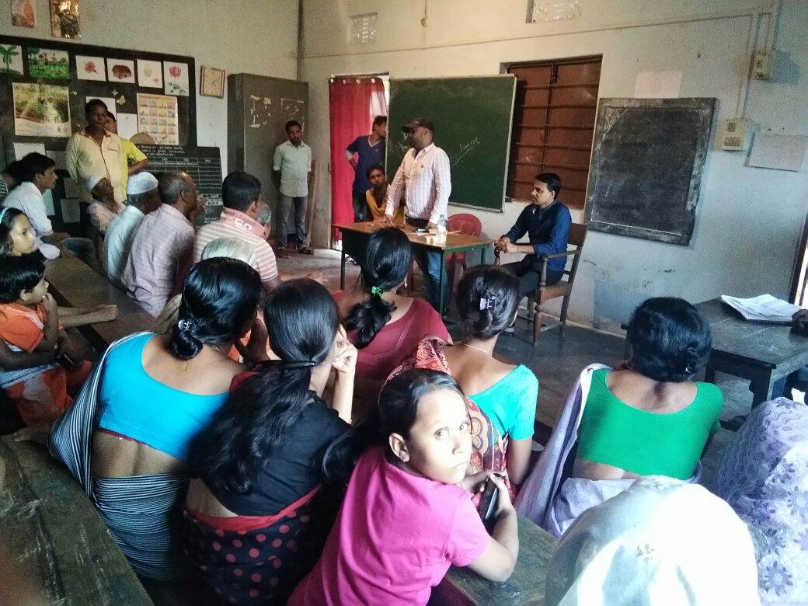
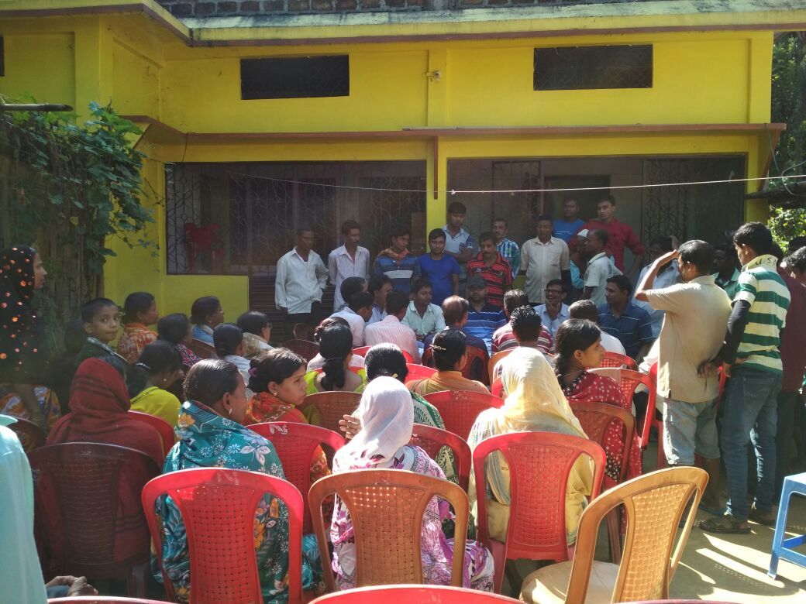
Picture 4.2: Orientation at various wards of Hailakandi Municipal Board

Awareness Programme

The awareness programme was held to make the people/stakeholders make aware about the scheme’s advantages or benefits to the town of Hailakandi. It was also done to make the guidelines or the policies transparent in front of the public. It was held in May 2017 for a month with the motive of extensively outreaching towards every citizen in the town. The following are the various awareness programmes:
- Meetings were held at ULB level to create awareness and to discuss about the scheme.
- Miking were done in slow moving vehicles in Bengali language.
- Public Awareness meetings were conducted in all the wards.
- Leaflets were distributed among all the households.
- Street plays were conducted at ward level in Bengali language.
- Banners and hoardings were installed in the market places and import places of the town in local languages.
- The forms were made available in newspapers, ward members, mission website, Common Service Centre, online Application and local NGOs.
Some Pictures related to Awareness Program are given below:

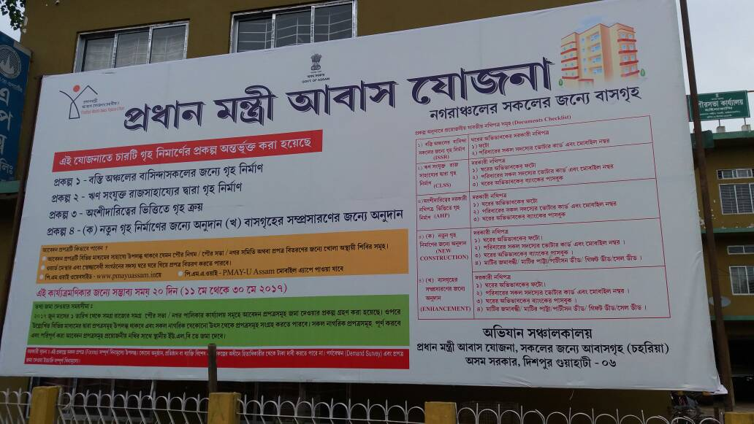
Picture 4.3: PMAY Hoarding in front of Hailakandi Municipal Board Office
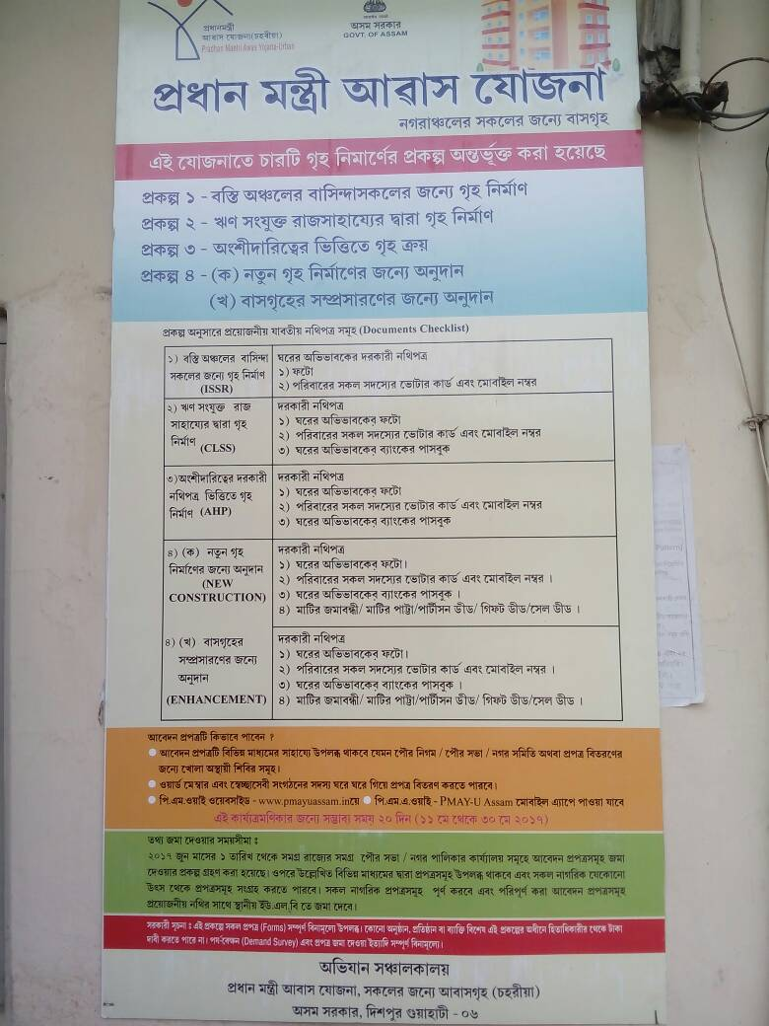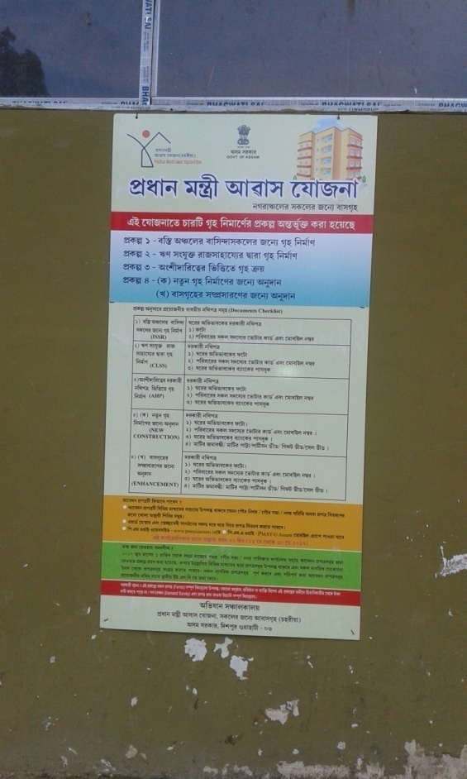

Picture-4.4: PMAY Information Board in Hailakandi D.C and Municipal Board Office

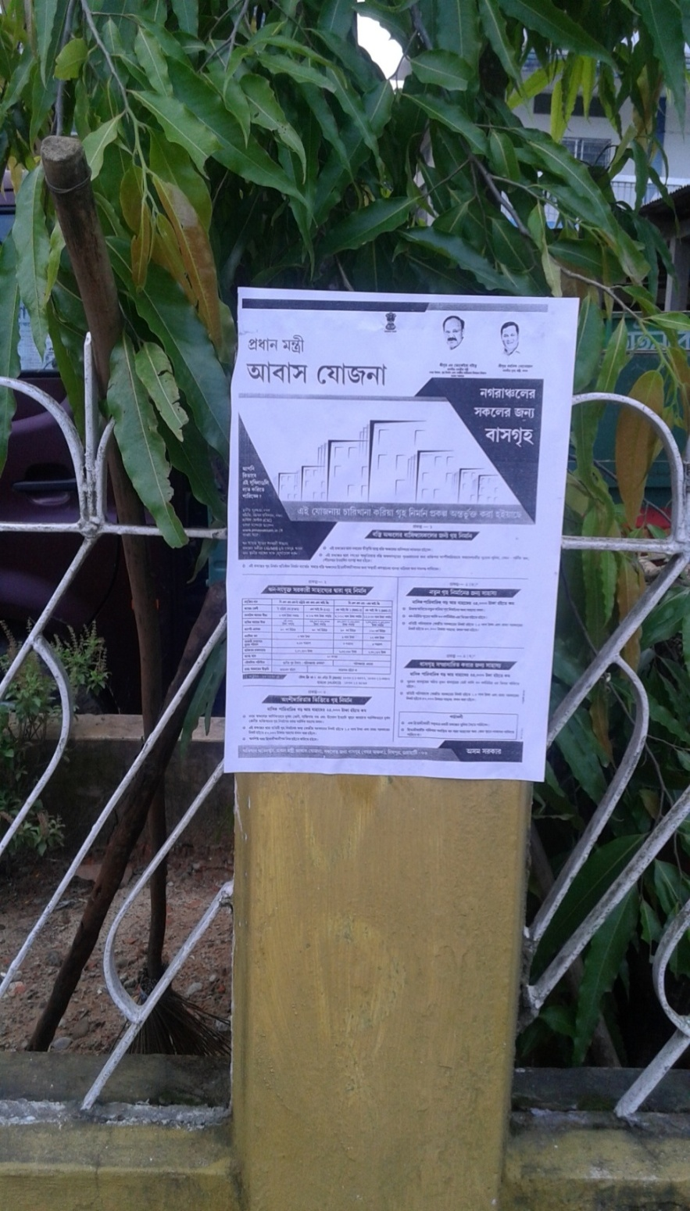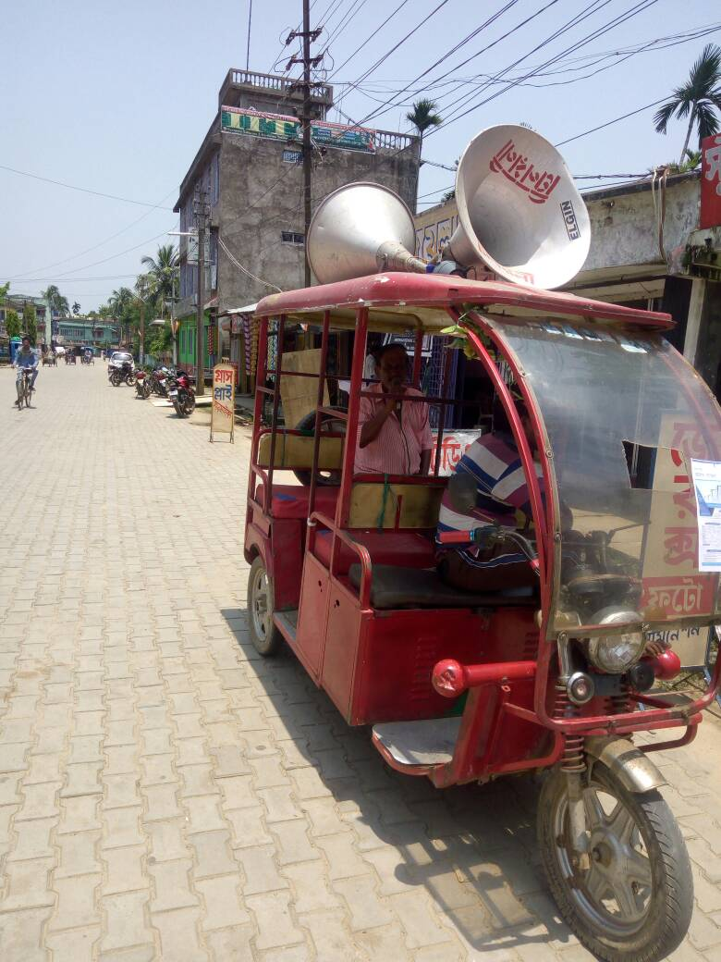

Picture-4.5: PMAY Leaflets in Hailakandi Town Picture-4.6: Miking in Hailakandi Town

Data Collection

The Data collection was initially decided for a week, which started from1st June’2017 to 7th June’2017. But, due to the public demand the last date was extended up to 14th June’2017 by the Mission Directorate. And with the further instruction by the Mission Directorate, form collection date was set till the 30th of June 2017. In the data collection stage the basic infrastructure was arranged in the ULB level. Manpower was engaged for collection of the forms after sufficient checking, also, multiple counters were set up for different activities such as replying queries from the public, completing the incomplete forms, checking the documents and collecting the forms.
A revenue camp was also set up on 15th and 16th July and 4th to 7th September to clarify all the doubts of both the parties about each other, where a lot of ineligible forms were rejected while many forms were accepted after rectifying the forms/documents.

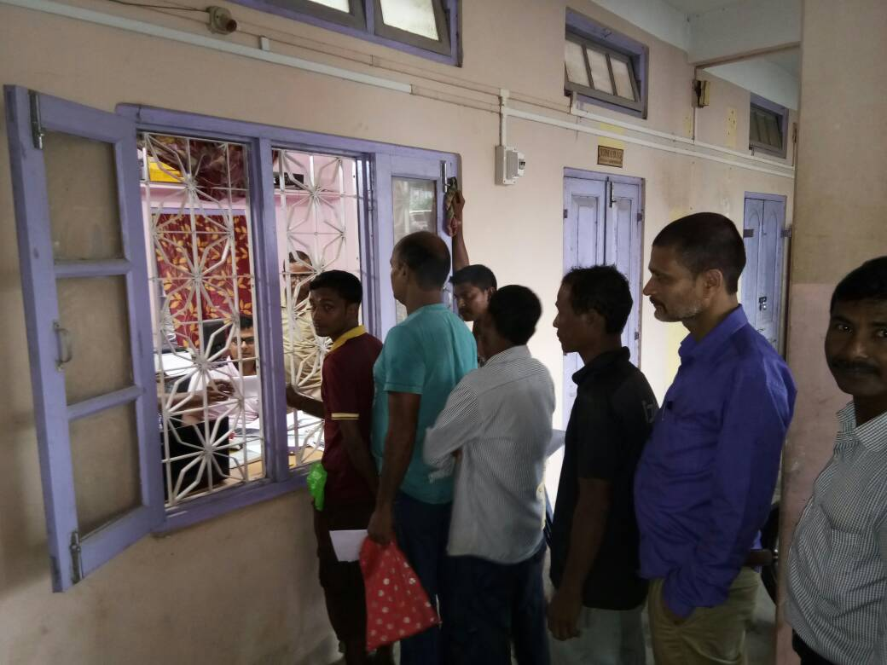

Picture-4.7: Form Collection at Hailakandi M.B Office

Data Entry

The collected data was then entered into a software named Low-Down, for which eligible candidates were hired in all the wards. Proper assurance was given to the manpower that she/he would work under the MIS expert and would not face any problem regarding while entering the data into the software. Proper space was allotted for the smooth data entry of PMAY-U along with desktops, ADF scanner and internet connection. This Data Entry process started from 22th June, 2017 and continued till 20th July 2017.

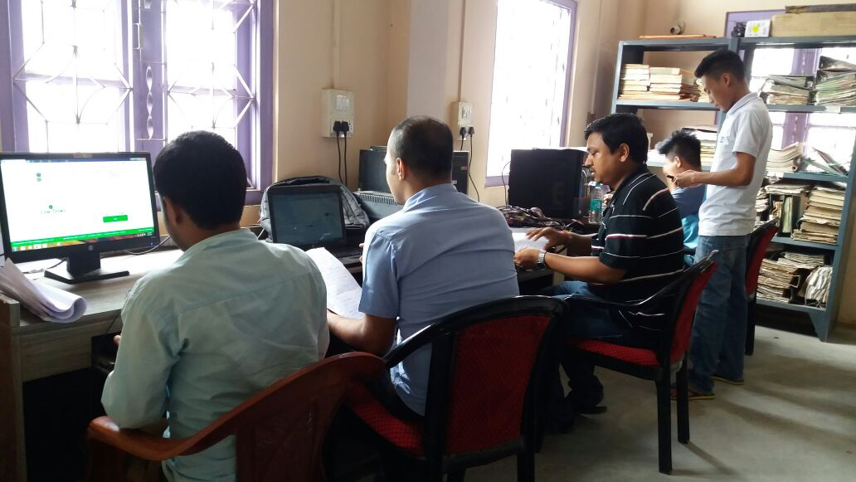

Picture-4.8: Data Entry by operators at Hailakandi M.B

House photo capturing

In this, all the houses proposed under Beneficiary led construction will be geo-tagged by the ULB and photographs will be captured as suggested by MoHUPA under the scheme. The surveyors will be identified who will be trained to use Mobile App for geo-tagging prepared by the Ministry and do the geo-tagging at 4 stages of construction. The Supervisor, who will be an ULB employee will oversee the process and will monitor. The whole mechanism will be put in place before construction starts on the ground. It will also help the State and respective ULB to ensure the scheme is not misused and real beneficiary gets the benefit of the scheme.

The preparatory activities for house photo capturing and geo-tagging through Android enabled smart phone:
- Engaging and training the manpower
- Collecting the 15 digit IMEI no of the respective smart phones and send it to the state MIS
- Installing the PMAY software needed for the activities
- Consolidating the state PMAY
The process flow for photo capturing are as followed:

- Splitting the surveyed households in the database into different areas
- Referring to the state MIS to locate the houses
- Capturing the house photos along with the location
Geo-Tagging process consists of the following 4 steps:
- On issue of letter of intent
- Sill level
- Plate level
- After completion
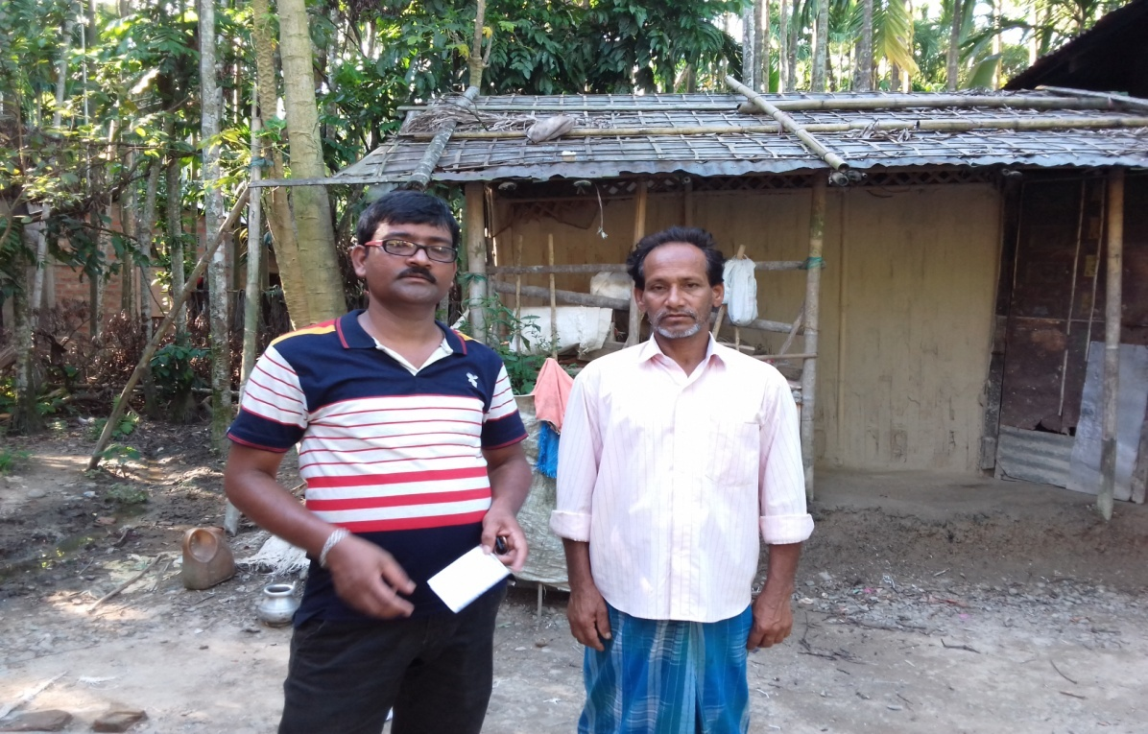

Picture-4.9: PMAY-HFA(U) House Photo capturing

4.2 Forms Collected and Data Entry Status

PMAY(U) forms were distributed at all the possible locations in the town viz. Hailakandi Municipal Board office, Weekly market place. At Hailakandi Municipal Board a total of 1802 nos. of forms were collected for Pradhan Mantri Awas Yojana (Urban), out of which, 1121 nos. are for BLC, 173nos are for BLE, 420 nos. for AHP and 88 nos. for CLSS . The data entry of 1802 nos. of forms is completed by Hailakandi Municipal Board.

4.3 Validation of Forms

- Verification of all the documents submitted by the beneficiaries are carried out by ULB Staffs in order to prevent the misuse of the scheme.
- In addition to that Temporary Camp has been setup at Hailakandi Circle office to verify the land documents by Mondols of the Hailakandi Circle Office.
- The list of the beneficiaries under BLC New was made public and individual Ward Commissioners are assigned to collect the documents for the verification.
- After due verification of documents, to check the duplicity, the Hailakandi Municipal Board invited claims and objections from the Public/Ward Commissioners to the said list. Again after verification with Ward Commissioners, the beneficiaries who did not concur to the scheme guidelines for PMAY(U) because of their existing house condition were excluded from the final Beneficiary list.

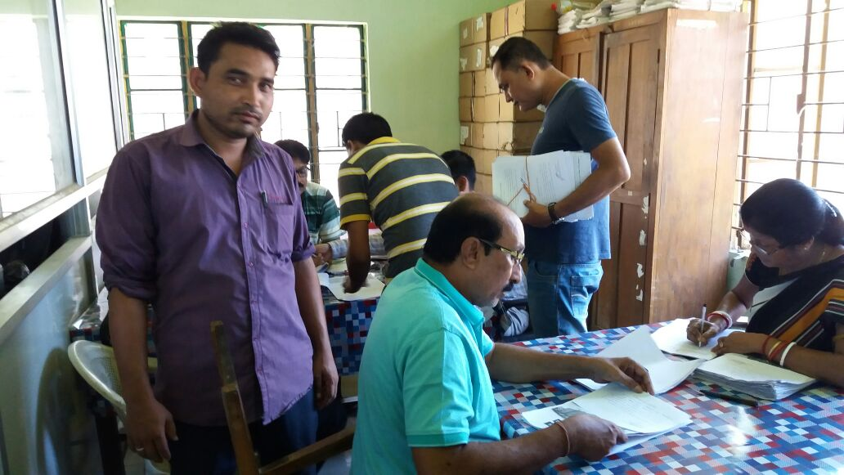

Picture-4.10: Revenue Camp at Hailkandi Circle Office

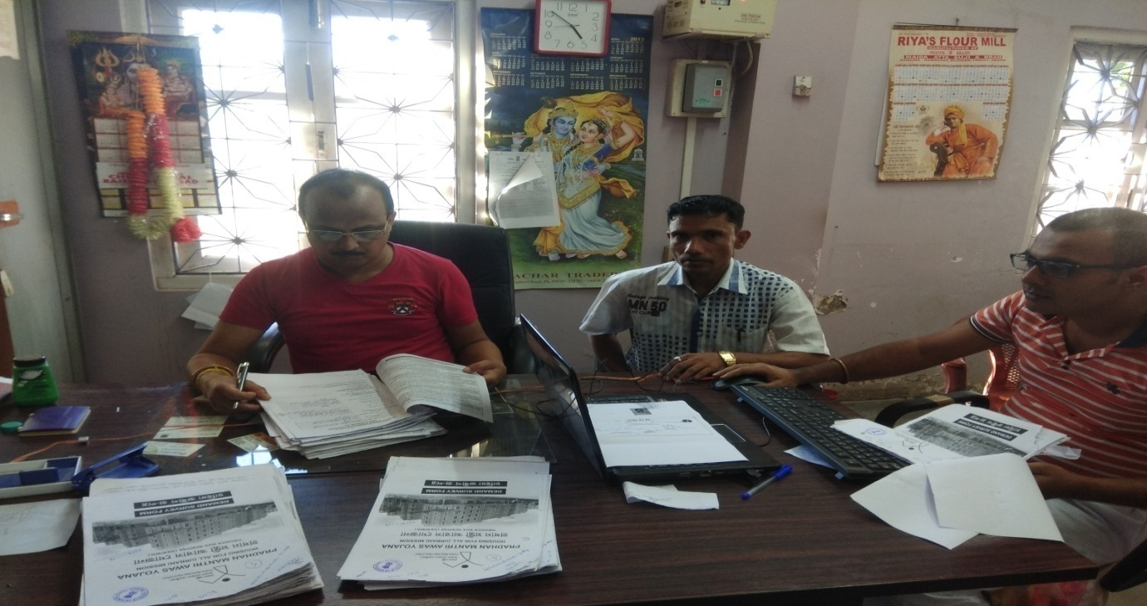

Picture-4.11: Verification of forms By ULB Officials

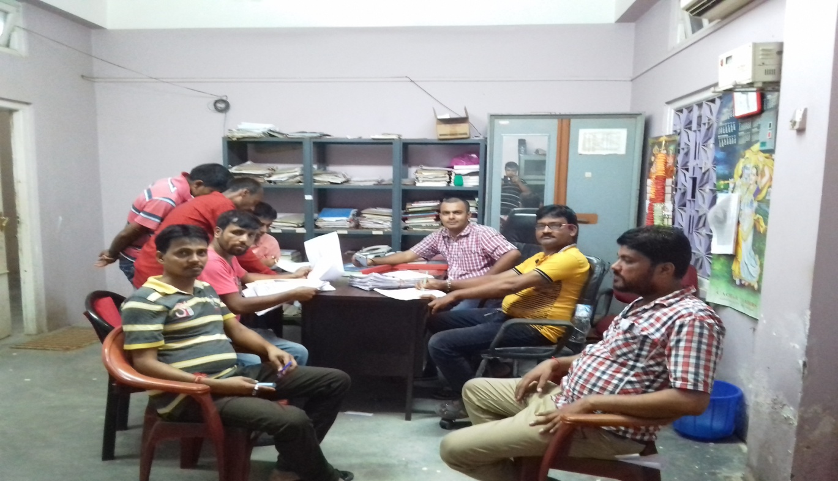

Picture-4.12: Verification of forms By ULB Officials along with ward commissioner

4.4 Slum in Hailakandi Municipal Board

There are no notified slums in Hailakandi Municipal Board Area but Hailakandi Municipal Board has few Slum Pockets. One of this slum pockets is Naga Patty Sweeper colony of ward no.-1, which exhibits slum like features. The land of Naga Patty sweeper colony belongs to Hailakandi Municipal Board. The households of Naga Patty sweeper colony are Hailakandi Municipal Board employees (mostly sweepers) and the houses of Naga Patty sweeper colony are given to them only as staff quarters. A board meeting has been conducted in Hailakandi Municipal Board on 19th January’2018, regarding slum redevelopment under PMAY-HFA(U), where resolution has been taken in favor of not to develop the Naga Patty sweeper colony under any verticals of PMAY-HFA(U), as it is the only land to accommodate municipal board employees such as sweepers and other daily wage workers. Apart from Naga Patty sweeper colony, the Hailakandi Municipal Board has aslo few slum pockets but the eligible households of these slum pockets have already applied for new houses under BLC vertical of PMAY-HFA(U). As there is no slum in Hailakandi Municipal Board area, hence there is no need of Slum demand survey or Slum redevelopment at Hailakandi Municipal Board.

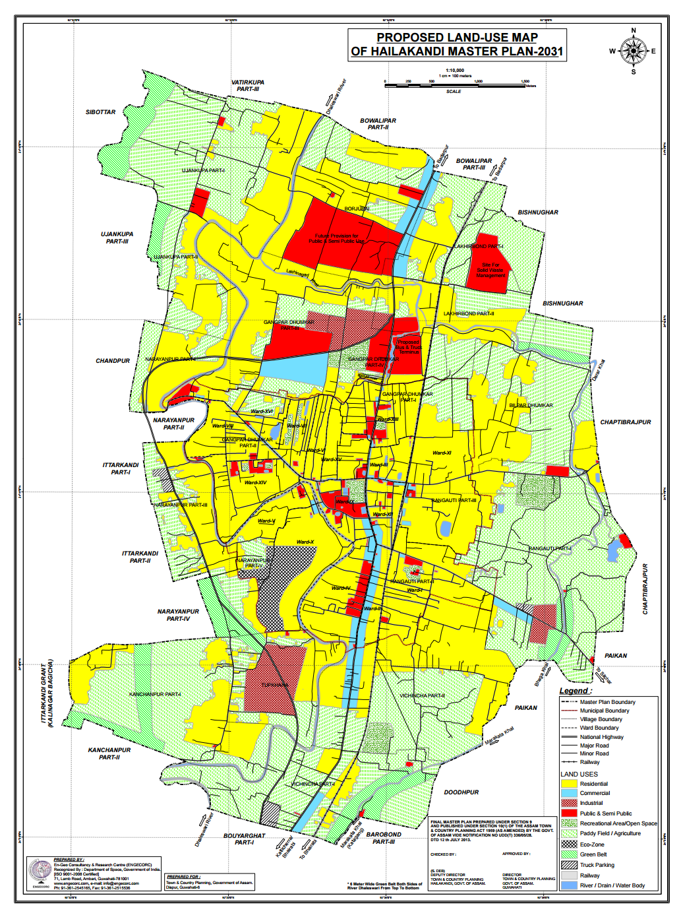

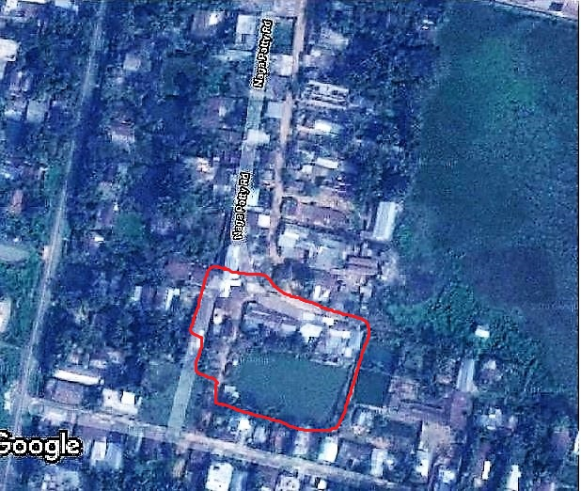
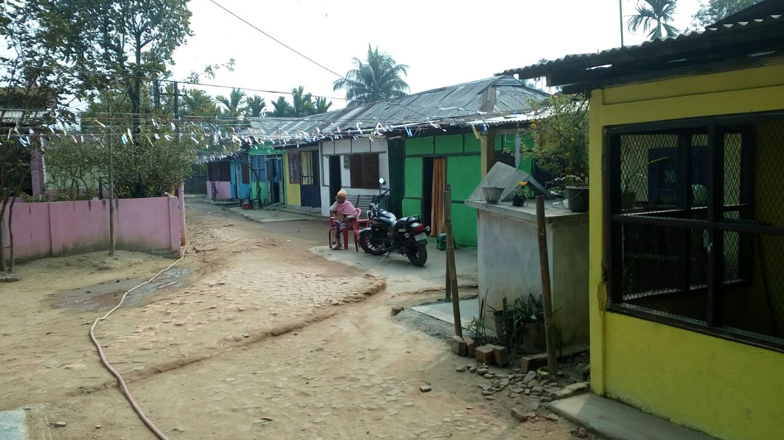
Pictures-4.13: Location of Naga Patty Sweeper Colony in Google map.

4.5 Checklist of beneficiaries

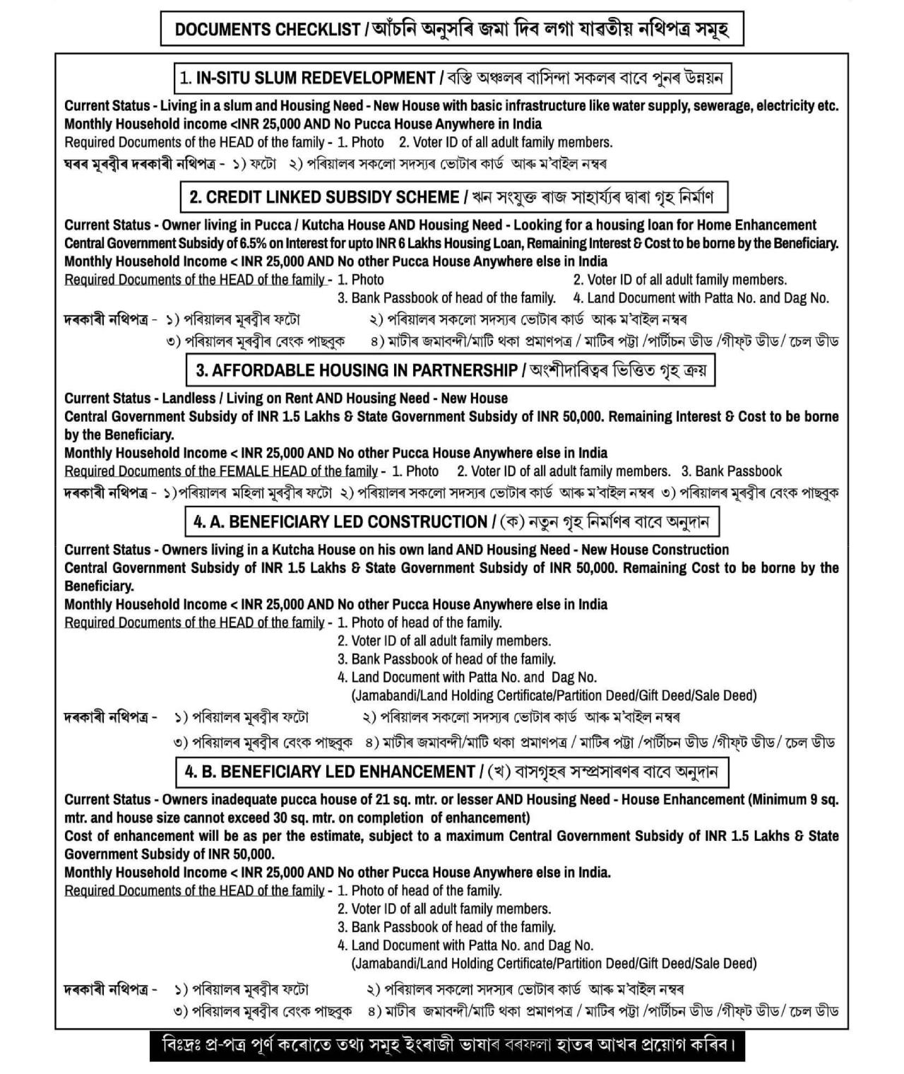

Chapter –5: Investment Plan

5.1 Introduction

Investment and financial planning is one of the crucial and an important part of any project. A proper financial plan considers all the circumstances, objectives and risk tolerance. It acts as a guide to choose the right types of investments to fit the needs and goals.
Under Pradhan Mantri Awas Yojana, PMAY-HFA (U), Housing for All Plan of Action (HFAPoA) will be prepared in such a way that it can reflect all the plans related to investment and Financial. In this chapter we will discuss the plan of action for the remaining five (5) financial years (i.e, 2017-2018, 2018-2019, 2019-2020, 2020-2021, 2021-2022) which includes the Project cost, Central share, State share, beneficiaries share etc.

5.2 Institutional Framework for Implementation of HFAPoA.

Table-5.1: Institutional framework at State, District and ULB level and their Roles and Responsibilities
Stakeholder | Community Participation | Planning | Implementation | Mandatory Conditions | Post Implementation
ULB | ✓ | ✓ | ✓ | ✓ | ✓
Urban Development Authority
Housing Board
Beneficiary |  |  | ✓
Private Sector |  | ✓ | ✓ |  | ✓

5.3 In-Situ Slum Redevelopment Feasibility

“In-situ” slum rehabilitation using land as a resource with private participation for providing houses to eligible slum dwellers is an important component of the “Pradhan Mantri Awas Yojana– Housing for All (Urban)” mission. Slums, whether on Central Government land/State Government land/ULB land, Private Land, should be taken up for “in-situ” redevelopment for providing houses to all eligible slum dwellers.
As a first step, all tenable slums as identified in Housing for All Plan of Action (HFAPoA) of the city should be analysed with respect to their location, number of eligible slum dwellers in that slum, area of the slum land, market potential of the land (land value as per ready reckoner can be used), FAR/FSI available and density norms applicable to that piece of land etc. On the basis of analysis of slums, the implementing authorities should decide whether a particular slum can be redeveloped with private participation or not using land as a resource and to provide houses to eligible slums dwellers. For making projects financially viable, in some cases, states and cities might have to provide additional FAR/FSI or TDR and relax density and other planning norms. States/UTs may also allow commercial usage for part of the land/FAR as mixed usage of the land.
State/ULB can also consider clubbing of nearby slums in clusters for in-situ redevelopment to make them financially and technically viable. Such cluster of slums can be considered as a single project

Table-5.2: In-Situ Slum Redevelopment Feasibility
Sl. No | Parameter | Unit | Calculation Method | Value
Estimation of land/built-up area:
a. | Total Slum Area | Sq. mts | a | N/A
b. | Total Slum Households | Nos. | b | N/A
c. | Eligible Slum Beneficiary Households determined by ULB (or) No. of Houses required | Nos. | c | N/A
d. | Permissible FSI/FAR | Nos. | d | N/A
e. | Total Built-up area permissible as per FSI/FAR norms | Sq.mts | e= a* d | N/A
f. | Proposed Super built-up area of each DU | Sq.mts | f | N/A
g. | Total Built-up Area required for in-situ redevelopment of eligible slum beneficiaries | Sq.mts | g=c*f | N/A
h. | Remaining Built-up area for sale component of private developer | Sq.mts | h=e - g | N/A
i. | Avg. cost of construction (including infra) | Sq.mts | i | N/A
j. | Cost of construction of Slum Rehab Component | No.s | j= g* i | N/A
k. | Cost of construction for built-up area under sale component | No.s | k= h* i | N/A
l. | Total investment made by developer | INR. | l= j + k | N/A
m. | Prevailing Market Value per Sq. mtr | INR. | m | N/A
n. | Selling Cost for built-up area under sale component | INR. | n= m* h | N/A
o. | Total Profit | INR. | o= n – l | N/A
p. | Profit Margin for developer | % | p= (o/ l)*100 | N/A

5.4 Exploring Feasibility by Incentivizing Developer

Additional FSI/FAR – Offer to developer additional FSI/FAR or additional built-up area.
“Floor Area Ratio” (FAR)/FSI: The quotient obtained by dividing the total covered area (plinth area) on all the floors by the area of the plot:

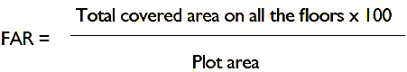

If States/Cities have some variations in this definition, State/City definitions will be accepted under the mission.
Under PMAY-HFA(U) the State/UTs shall provide additional FAR/FSI and relaxed density norms for low cost housing if required. It will be decided by the respective State/UTs.

Transfer of Development Rights (TDRs) – Transfer of Development Rights is making available certain amount of additional built up area in lieu of the area relinquished or surrendered by the owner of land, so that he can use extra built up area himself in some other land.
Under PMAY-HFA(U) the State/UTs shall provide lucrative TDR polices which incentivizes the developer for constructing in-situ redevelopment projects.

5.5 Implementation / Planning process for ISSR, BLC and AHP

Figure 5.1: Institutional Framework for implementation of HFAPoA

5.5.1 Slum-wise Intervention strategies for Tenable slums

(Annexure I)
Slum-wise Intervention strategies for Tenable Slums

Name of the Slum | Area of the Slum in sq. mts | Total no of Slum Households as per Demand survey | Eligible Slum Households | Whether ‘in-situ’ redevelopment with Private Participation | Required Area for in-situ Redevelopment in Sq.mts | FSI / FAR |  | Name of other slum if proposed for resettlement in this slum | Proposed Year of intervention
 |  |  |  |  |  | Existing | Proposed | Name of other slum if proposed for resettlement in this slum | Proposed Year of intervention
N/A | N/A | N/A | N/A | N/A | N/A | N/A | N/A | N/A | N/A
NO TENABLE SLUM UNDER HAILAKANDI MUNICIPAL BOARD

5.5.2 Slum-wise Intervention strategies for Untenable Slums

(Annexure II)
Slum-wise Intervention strategies for Untenable Slums

Name of the Slum | Area of the Slum in sq.mts | Total no of Slum Households as per Demand survey | Proposed Development Strategy |  |  |  | Proposed  Year of  intervention
Name of the Slum | Area of the Slum in sq.mts | Total no of Slum Households as per Demand survey | Affordable Housing Project  (AHP) | Credit Linked Subsidy Scheme  (CLSS) | Beneficiary Led Construction | Clubbing with other Tenable Slums | Proposed  Year of  intervention
N/A | N/A | N/A | N/A | N/A | N/A | N/A | N/A
NO UNTENABLE SLUM UNDER HAILAKANDI MUNICIPAL BOARD

5.5.3 Year-wise Proposed Interventions in Slums

(Annexure III)
Year-wise Proposed Interventions in Slums

Year | Number of Beneficiaries and Central Assistance Required (Rs. in Crores)
Year | Redevelopment through Private Participation |  |  | Beneficiary Led Construction |  |  | Credit Linked Subsidy |  |  | Affordable Housing in Partnership |  |  | Total
Year | No. of Slum | No of Benefi-ciaries | Amount | No. of Slum | No of Benefi-ciaries | Amount | No. of Slum | No of Benefi-ciaries | Amount | No. of Slum | No of Benefi-ciaries | Amount | No of Benefi-ciaries | Amount
2015-16 | 0 | 0 | 0 | 0 | 0 | 0 | 0 | 0 | 0 | 0 | 0 | 0 | 0 | 0
2016-17 | 0 | 0 | 0 | 0 | 0 | 0 | 0 | 0 | 0 | 0 | 0 | 0 | 0 | 0
2017-18 | 0 | 0 | 0 | 0 | 0 | 0 | 0 | 0 | 0 | 0 | 0 | 0 | 0 | 0
2018-19 | 0 | 0 | 0 | 0 | 0 | 0 | 0 | 0 | 0 | 0 | 0 | 0 | 0 | 0
2019-20 | 0 | 0 | 0 | 0 | 0 | 0 | 0 | 0 | 0 | 0 | 0 | 0 | 0 | 0
2020-21 | 0 | 0 | 0 | 0 | 0 | 0 | 0 | 0 | 0 | 0 | 0 | 0 | 0 | 0
2021-22 | 0 | 0 | 0 | 0 | 0 | 0 | 0 | 0 | 0 | 0 | 0 | 0 | 0 | 0
Total | 0 | 0 | 0 | 0 | 0 | 0 | 0 | 0 | 0 | 0 | 0 | 0 | 0 | 0

5.5.4 Year-wise Proposed Interventions for Other Urban Poor based on demand survey

(Annexure IV)
Year-wise Proposed Interventions for Other Urban Poor based on demand survey

Year | Number of Beneficiaries and Central Assistance Required (Rs. in Crores)
Year | Beneficiary Led Construction |  | Credit Linked Subsidy |  | Affordable Housing in Partnership |  | Total
Year | No of Beneficiaries | Amount | No of Beneficiaries | Amount | No of Beneficiaries | Amount | No of Beneficiaries | Amount
2015-16 | 0 | 0 | 0 | 0 | 0 | 0 | 0 | 0
2016-17 | 0 | 0 | 0 | 0 | 0 | 0 | 0 | 0
2017-18 | 956 | 19.12 | 88 | 2.3496 | 0 | 0 | 1,044 | 21.4696
2018-19 | 173 | 3.46 | 0 | 0 | 420 | 8.40 | 593 | 11.86
2019-20 | 0 | 0 | 0 | 0 | 0 | 0 | 0 | 0
2020-21 | 0 | 0 | 0 | 0 | 0 | 0 | 0 | 0
2021-22 | 0 | 0 | 0 | 0 | 0 | 0 | 0 | 0
Total | 1129 | 22.58 | 88 | 2.3496 | 420 | 8.40 | 1637 | 33.3296

5.6 Year-wise targets under different components

(Annexure V)
Year-wise targets under different components

Interventions |  | Number of Beneficiaries and Central Assistance Required (Rs. in Crores) |  |  |  |  |  |  |  |  |  |  |  |  |  | Total
Interventions |  | 2015-16 |  | 2016-17 |  | 2017-18 |  | 2018-19 |  | 2019-20 |  | 2020-2021 |  | 2021-2022
Interventions |  | No | Amt | No | Amt | No | Amt | No | Amt | No | Amt | No | Amt | No | Amt | No | Amount
Redevelopment through Private Participation | Slums | 0 | 0 | 0 | 0 | 0 | 0 | 0 | 0 | 0 | 0 | 0 | 0 | 0 | 0 | 0 | 0
Subsidy for beneficiary-led/improvement of existing house | Slums | 0 | 0 | 0 | 0 | 0 | 0 | 0 | 0 | 0 | 0 | 0 | 0 | 0 | 0 | 0 | 0
Subsidy for beneficiary-led/improvement of existing house | Non-Slums | 0 | 0 | 0 | 0 | 956 | 19.12 | 173 | 3.46 | 0 | 0 | 0 | 0 | 0 | 0 | 1129 | 22.58
Credit linked subsidy to individual beneficiaries | Slums | 0 | 0 | 0 | 0 | 0 | 0 | 0 | 0 | 0 | 0 | 0 | 0 | 0 | 0 | 0 | 0
Credit linked subsidy to individual beneficiaries | Non-Slums | 0 | 0 | 0 | 0 | 88 | 2.3496 | 0 | 0 | 0 | 0 | 0 | 0 | 0 | 0 | 88 | 2.3496
Affordable Housing in Partnership | Slums | 0 | 0 | 0 | 0 | 0 | 0 | 0 | 0 | 0 | 0 | 0 | 0 | 0 | 0 | 0 | 0
Affordable Housing in Partnership | Non-Slums | 0 | 0 | 0 | 0 | 0 | 0 | 420 | 8.40 | 0 | 0 | 0 | 0 | 0 | 0 | 420 | 8.40
Total |  | 0 | 0 | 0 | 0 | 1044 | 21.4696 | 593 | 11.86 | 0 | 0 | 0 | 0 | 0 | 0 | 1637 | 33.3296

5.7 Summary Sheet for Annual Implementation Plan (AIP) for the year 2017-2018

(Annexure VI)
Summary Sheet for Annual Implementation Plan (AIP) for the year 2017-2018

Admissible Components | Target of Year 2016-17 | Achievement for year 2016-17 | Target for year 2017-18 | Remaining Target as Per HFAPoA
A. Beneficiary-Led Construction
* New House | 0 | 0 | 956 | 956
* Enhancement | 0 | 0 | 0 | 0
* Sub Total (A) | 0 | 0 | 956 | 956
B. In-Situ Slum Rehabilitation with Participation of Private Sector
* Number of Slums | 0 | 0 | 0 | 0
* Number of Households (B) | 0 | 0 | 0 | 0
C. Affordable Housing in Partnership (EWS Category) (C)
 | 0 | 0 | 0 | 0
D. Credit Linked Subsidy
* EWS Households | 0 | 0 | 88 | 0
* LIG Households | 0 | 0 | 0 | 0
* Sub Total (D) | 0 | 0 | 88 | 0
E. Total (A+B+C+D) | 0 | 0 | 1044 | 1044



5.8 Conclusion

The officials of ULB has accomplished door to door PMAY-HFA(U) Demand survey, and prepared Housing For All Plan of Action (HFAPoA) for Hailakandi Municipal Board town under Pradhan Mantri Awas Yojana- Housiong for all (Urban) . During verification of forms, it is found that land ownership is the main challenge, which was faced at Hailakandi. A major portion of the beneficiary applied under BLC New, lives in a disputed land. Land documents of all Beneficiaries are verified by Lot Mondols at Hailakandi Circle Office, and beneficiaries living in disputed land are not included in the DPR.

THANK YOU

http://www.mckinsey.com/global-themes/urbanization/indias-urbanization-a-closer-look
http://icrier.org/pdf/FinalReport-hpec.pdf
https://www.google.co.in/url?sa=t&rct=j&q=&esrc=s&source=web&cd=2&cad=rja&uact=8&ved=0ahUKEwiW5__Q95TUAhWBvo8KHaBgC50QFggrMAE&url=http%3A%2F%2Fwww.naredco.in%2Farticle%2Fpdfs%2FHousing%2520Scenario%2520in%2520India.doc&usg=AFQjCNGWfw45fDpD2OBt5P-Br3VKNh07pA&sig2=20QIIhrnwheUw2LEZz5jgA
12thplan.gov.in
https://www.nbmcw.com/construction-infra-industry/18645-indian-housing-scenario-problems-and-remedies.html

